Unit 1.1: States / Phases of Matter
Further Reference: 3.2 Changes of State
MATTER
- Matter is ____________________________________________________________

- The 4 states of matter are:
  - ___________________
  - ___________________
  - ___________________
  - ___________________
    - Each state of matter is designated by the _________________, ________________, and behavior of the __________________
- Each state of matter has a different:
  - _____________________________________
  - _____________________________________
  - _____________________________________
  - _____________________________________

- _______________ determines the kinetic energy ( and thus the _______________) of a substance.
KINETIC THEORY OF MATTER
- The Kinetic Theory of Matter: (AKA _____________________)

1. ___________________________________________________
2. ___________________________________________________
3. ___________________________________________________
STATES / PHASES OF MATTER
- Solids:
  - Energy: _______________________________________
  - Movement: ___________________________________________________
  - Particle Spacing _______________________________________________
  - Volume Shape: ___________________ volume, ______________ shape
- Liquids:
  - Energy: _______________________________________
  - Movement: ___________________________________________________
  - Particle Spacing _______________________________________________
  - Volume Shape: ___________________ volume, ______________ shape
- Gasses:
  - Energy: _______________________________________
  - Movement: ___________________________________________________
    - Enough energy __________________________________________
  - Particle Spacing _______________________________________________
  - Volume Shape: ___________________ volume, ______________ shape
- Plasma is _______________________________________________________
  - Created at __________________________________
    - Seen in ____________________________
  - It is the most abundant state of matter ___________________________
    - NOT the most abundant ________________

CHANGES IN STATES / PHASES OF MATTER
- Increase in energy:
  - _____________________________________________

  - _____________________________________________

- Decrease in energy:
  - _____________________________________________

  - _____________________________________________

- Melting point _________________________________________________
  - Example:

- Freezing point _________________________________________________
  - Example:

- Boiling point ___________________________________________________
  - Example:

- condensation __________________________________________________
  - Example:

- Sublimation ___________________________________________________
  - Example:

- Deposition ____________________________________________________
  - Example:
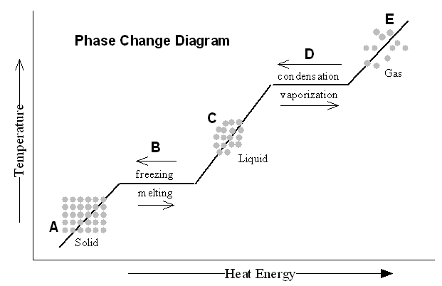

PHASE CHANGE DIAGRAM
- When changing from solid to liquid, the substance isn’t entirely___________ until the graphhas a ____________ slope

- At point A the substance is ___________________
- At point B the substance is ___________________
- At point C the substance is ___________________
- At point D the substance is ___________________
- At point E the substance is ___________________

Unit 1.3: Composition of Matter
Further Reference: 2.1 Classifying Matter
MATTER
- Matter is ____________________________________________________________

- The two categories of matter are:
  - ________________________

  - ________________________

SUBSTANCES
- The two categories of substances are:
  - ___________________

  - ___________________

- Elements are _________________________________________________________

  - There are ___________ known elements, with ________ of them occurring naturally.

  - It is only an element if _________________________________________

  - Element symbols are written with the 1st letter _______________, and the 2nd letter ________________

    - Ex: Hydrogen = _____ Carbon = _____ Calcium = _____

  - Atom is ______________________________________________________

    - All atoms for one element are ______________

- Compounds are ______________________________________________________

  - They are ________________________________
    - Ex: CO₂ H₂O NaCl C₆H₁₂O₆

  - If you see 2 different _________________ written together with no spaces, it is a __________________

  - Physical processes ____________________ separate compounds

  - Compounds have a different _________________ and _______________ than the elements that make them up

  - Molecule is __________________________________________________

    - These atoms do not need to be ___________________________.

      - Ex: H-H is a _______________. H₂O is also a ____________

    - Molecules are the ______________form of a compound that can exist and still have the _____________________ of that compound

MIXTURES
- Mixtures contain _____________________________________ that IS NOT ______________________________ together.

- Mixtures can be __________________________________________

- The two categories of mixtures are:
  - ___________________

  - ___________________

- Heterogenous Mixtures occur when matter is ______________________________________________________

  - Different parts have easily ____________________________

  - Example: ____________, ________________, _______________

  - CAN be ___________________________________

- Homogenous Mixtures occur when matter is ______________________________________________________

  - Example: ____________, ________________, _______________

  - Homogenous mixtures are also called a __________________________

  - CAN be ___________________________________

RECAP
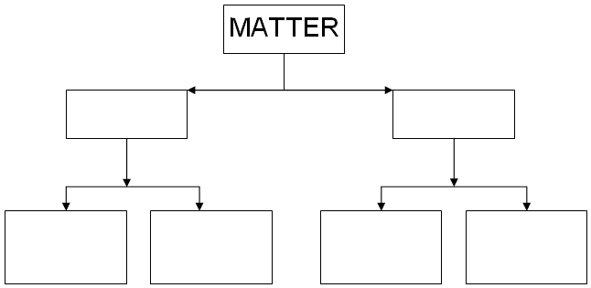

Unit 1.4: Chemical vs Physical: Properties and Changes

Further Reference: 2.1 Properties of Matter and 2.2 Properties of Matter

PHYSICAL
- Physical properties are any observations that can be made ___________________ the composition of matter
  - Examples include:
    - _______________ _______________ _______________

    - _______________ _______________ _______________

    - __________________________ __________________________

    - __________________________ __________________________

- Physical changes are a change in ______________________________.

  - The identity of the element or compound ____________________

  - _________________ make or break bonds.

- Examples include:
  - Any ________________________________ (________________________)

    - Rubbing alcohol ______________________________

    - A juice box _____________________________

    - Butter __________________________________

  - Any ________________________________ (________________________)

    - Aluminum foil ______________________________

    - Clay _____________________________

    - Chewing __________________________________

- Signs of a Physical Change include:

  - Any ____________________

  - Change in the ______________________

  - What you started off with is __________________________________

CHEMICAL
- Chemical properties are any observations that are dependent upon ________________________________ of the object

  - Examples include:
    - __________________________ __________________________

    - __________________________ __________________________

- Chemical changes: The substances that are present at the beginning of the reaction are ______________________________.

  - _________________ make or break bonds.

  - The change __________________

- Examples include:
  - Gasoline _________________________________

  - Car _____________________________

  - Milk ____________________________

  - Bread _____________________________

  - Hydrogen peroxide __________________________________

  - Food digesting ______________________________________________

  - Any ________________________________ (________________________)

- Signs of a Chemical Change include:

  - Bubbles ____________________________

  - _______________ something.

  - A _____________ forms (solid appears)

  - A ____________________________

  - The ______________________ changes

  - There is a different _______________________

Unit 1.5: Density

Further Reference: 2.2 Properties of Matter

DENSITY
- Density is defined as ___________________________________

  - It is a measure of __________________________________ are in an object

  - Basically, it is the _________________________ within ________________
Equation in words Equation in Symbols

Units:
Mass = _______________ (__)

Volume (2 ways)
Ruler = ___________________ (__)
Displacement = ___________________ (____)

Density (2 ways)
Ruler = ___________________ (__)
Displacement = ___________________ (____)

DIFFERENT OBJECTS HAVE DIFFERENT DENSITIES

- Each substance __________________________________________

  - It does not matter _______________________________ you have, it will have ______________________

  - Distilled water has a density of _________________________

  - Objects with different densities will always interact, with the more dense object __________________ and the less dense __________________

- Is Ice or Distilled Water more dense? ___________ because __________________

  - Objects with more than a density of ______________ will ____________ in tap water
    - Example:

  - Objects with less than a density of ______________ will ______________ in tap water
    - Example:

DETERMINING DENSITY

- Step 1: __________________________________________

- Step 2: __________________________________________
  - 2 ways to determine volume:

    - _______________________________

    - _______________________________

- Step 3: __________________________________________

PRACTICE PROBLEMS: Show: the formula, your work, and an answer, include units.
- If the mass of an object is 35 grams and it takes up 7 cm³ of space, calculate the density.

- Osmium is a very dense metal. What is its density in g/cm³ if 50.00 g of the metal occupies a volume of 2.22cm³?

- What is the density (g/cm³) of 48 g of a metal if the metal raises the level of water in a graduated cylinder from 25 mL to 33 mL?

Unit 1 Study Guide

- What is matter?

- List the 3 steps of the Kinetic Theory of Matter / Atomic Theory:

1.__________________________________________________________________________________________________

2. __________________________________________________________________________________________________

3. _________________________________________________________________________________________________
Draw a picture of what the particles of each state of matter would look like in the container |  | Volume:  Does this state of matter have a definite Volume? (Definite or Not Definite) |  | Shape:  Does this state of matter have a definite shape (Definite or Not Definite) |  | Describe the movement of the particles. (Slow? Fast? How do they move?) |  | How closely are the particles packed? (Close together? Spread apart?)
Solid:

Liquid:

Gas:

 | Phase Change |  | Between what 2 states of matter? |  | What’s happening to the particles as they change from one state to another? |  | Example of Phase Change
 | Condensation
 | Evaporation
 | Freezing
 | Melting
 | Sublimation
 | Deposition

Classification of matter:
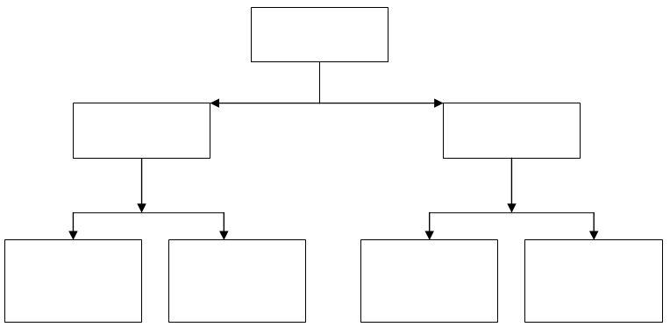

Word Bank: Mixtures, Compounds, Matter, Homogeneous, Element, Substance, Heterogeneous

1. ____________ have only one type of matter and cannot be physically separated

2. ____________ are made up of multiple things and the different parts are easily distinguishable.

3. ____________ are two or more elements chemically bonded together.

4. ____________ are made up of multiple types of matter and are classified based on how thoroughly blended they are.

5. ____________ are defined as having all the atoms exactly the same. Cannot be broken down into smaller parts.

6. ____________ contains multiple types of matter, but they are distributed evenly throughout.

Chemical vs Physical Changes
- What is a physical property?

- What is a physical change?

- What are 3 signs that a physical change occurred?

- What is a chemical property?

- What is a chemical change?

- What are 6 signs that a chemical change occurred?

Tell me if the following is a Physical or Chemical Change:
- Vinegar and baking soda volcano 10. Cutting a steak

- Ice cream melting 11. Burning paper

- Crushing a car at a junk yard 12. Rust forming

Separating Mixtures:
- Do you separate an element by chemical or physical means?

- Do you separate a compound by chemical or physical means?

- Do you separate a heterogeneous mixture by chemical or physical means?

- Do you separate a homogenous mixture by chemical or physical means?

- How can you separate salt water into salt and water?

- How can you separate alcohol from water?

