Unit 2.1: Atomic Structure

Further Reference: 4.2 Structure of Atoms

THE ATOM
- The atom is _________________________________________________________

  - It is the basic building block ______________________

  - The atom is made of the following 3 parts:

    - _______________, ___________________, _________________

- The atom is composed of 2 parts: the ______________ and the ________________

  - The nucleus is ______________ charged

    - Contains ______________ and ______________

    - Protons are _________________ charged

    - Neutrons are _______________ charged

      - Neutrons act like____________ for the nucleus

  - The electrons are ______________ charged

    - Electrons occupy the ________________________ around the nucleus

    - Electrons are arranged into ____________ or ______________

    - Electrons are _________ moving in _______________________ around the nucleus. Their movement is ___________________

    - The electron cloud give us _____________________ location

 | Location | Charge | Mass | Special Fact
Protons
Neutrons
Electrons

PROPERTIES OF ATOMS
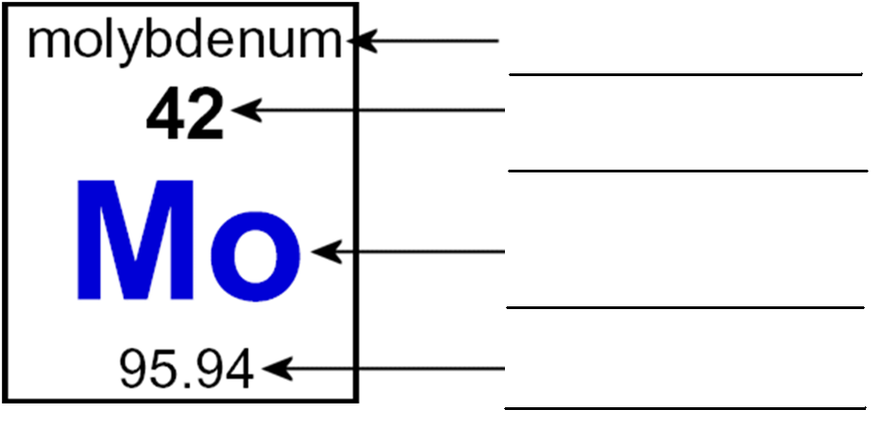

- Atomic number is ______________________________________________________________________

  - Each element has its _____________________________________________________________

  - In a NEUTRAL ATOM, this is also ____________________________________________________

- (Average) Atomic Mass is ________________________________________________________________

_________________________________________________________________

- Mass number is the ____________________________________________________________________

  - It is the sum of the ______________ and _____________ in the nucleus

  - Mass number = ___________________ + _____________________
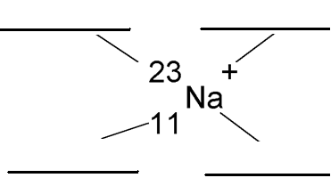
- Isotope Notation:

PRACTICE WITH ELEMENT PARTS

Element | Symbol | Atomic # | Protons | Neutrons | Mass #
Boron – 11 | B
Carbon – 12 |  |  | 6 | 6
Magnesium – 23 |  | 12 |  |  | 23
Copper – 64 |  | 29 |  | 35
 |  |  |  | 20

Unit 2.2: Isotopes and Ions

Further Reference: 4.2 Structure of Atoms

ISOTOPES
- Isotopes are _________________________________________________________

  - Two isotopes of an element will have the same _________________ but different _______________________ (and _____________________)

  - Looking at the carbon atoms to the right:
    - What is the mass number of the carbon atom on the left _______

    - What is the mass number of the carbon atom on the right ______

    - What is the atomic number of the carbon atom on the left ______

    - What is the atomic number of the carbon atom on the right ______

- Isotope notation you write the _________________ with the _________________ on the top left and the

___________________ on the bottom left

  - Write an example of carbon-14 __________________________

 | ₇ ¹⁴ N | ₇ ¹⁵ N | ₇ ¹⁶ N
Protons
Neutrons
Electrons

IONS
- Ions are atoms or groups of atoms with a _____________ or a _____________ charge
  - Ions differ in the number of _____________

    - For neutral atoms are where the number of electrons are ____________ to the number of protons

    - For ions, the __________ stay the same and the ____________ are

different. You can either _________ or ___________ electrons.

  - Examples of Neutral Atoms: _______, _______, _______, _______

  - Examples of Ions: ________, ________, ________, ________

- Taking away an electron gives an atom a _____________ charge because there are now more _______________

  - This is called a _______________

  - So if the Mg atom loses 2 electrons, it becomes _____________

- Gaining an electron gives an atom a _____________ charge because there are now more __________________

  - This is called a _______________

  - So if the F atom gains 1 electron, it becomes ________________

 | ₁₉ ³⁹N⁺ | ₈ ¹⁶N⁻² | ₂₀ ⁴¹N⁺²
Protons
Neutrons
Electrons

Unit 2.3: Electron Arrangement

Further Reference: 4.3 Modern Atomic Theory
ENERGY LEVELS
- Electrons that are closer to the nucleus have ____________ energy

  - Further away from the nucleus means you have __________ energy

- Each level (or shell) has a maximum number of __________ that it can hold.
  - 1st level = ______________
  - 2nd level = ______________
  - 3rd level = ______________
  - 4th level = ______________

- Electrons must occupy the __________________________________________ first

BOHR DIAGRAMS
- Bohr diagrams show the _____________________ of the atom

  - They show __________________ that an atom has orbiting around it.

- These electrons are organized into different _____________ or _______________

  - ____________ = 2 electrons

  - ____________ = 8 electrons

  - ____________ = 18 electrons

- Draw the following Bohr Diagrams:

H | B
F | Si

- Valence electrons are electrons __________________________________________

  - Valence electrons determine the _______________________________________________________

  - Each column has a ____________________________________________________

    - Sodium (Na) has ____________ valence electrons

    - Boron (B) has ____________ valence electrons

    - Chlorine (Cl) has ____________ valence electrons

    - Neon (Ne) has ____________ valence electrons

LEWIS DOT DIAGRAMS
- Lewis dot diagrams use the symbol and dots to represent _____________________

  - How to…
    - Write the ______________ of the element

    - Figure out how many ______________________ it has

    - Each side of the symbol can only hold ___________________

      - 1 dot = ___________________

      - Each side must get _______________ before any side can get ________________

    - Maximum number is __________dots

- Draw the following Lewis Dot:

H | Al
Cl | Ne

