Periodic Table Recap
A H
B C D E F G

I

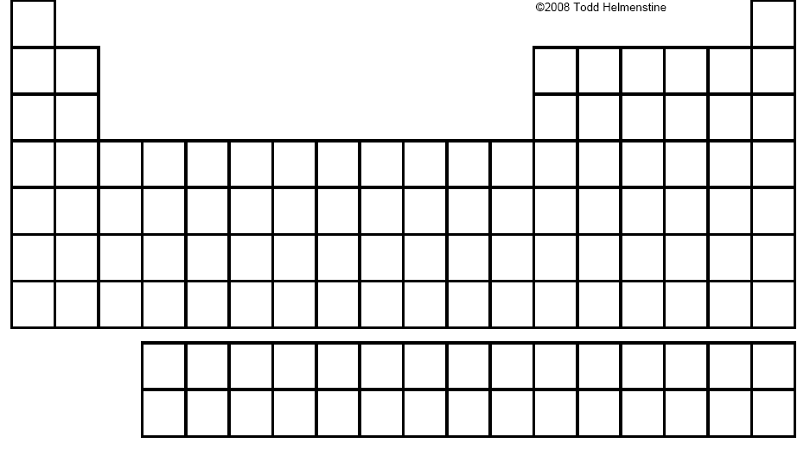
Write the names and valence electrons for each of the letters above on the periodic table:
 | Name of Group | Valence Electrons
A
B
C
D
E
F
G
H
I

- Where are the metals located on the periodic table?

- Where are the non-metals located on the periodic table?

- Where are the metalloids located on the periodic table?

- Why is H located to the top left of the periodic table (with the Alkali Metals)?

- Why is He located to the top right of the periodic table (with the Noble Gasses)?

- What do we call a group of elements going up and down?

- What do we call a group of elements going side to side?

- What properties do we notice as we move from top to bottom down a group of elements?

- What properties do we notice as we move from left to right across a group of elements?

