States of Matter

- What is matter?

- What are the three parts of kinetic theory?

–

–

–

- What determines the kinetic energy found within a substance?

- What are the 4 states of matter?

- What are the characteristics of a solid? (Use the words shape, volume, and explain the energy of the particles)

- What are the characteristics of a liquid? (Use the words shape, volume, and explain the energy of the particles)

- What are the characteristics of a gas? (Use the words shape, volume, and explain the energy of the particles)

- If plasma is found at very high temperatures, what can you tell me about how the molecules in plasma are moving?

- Can matter change phases?

- What causes matter to change states/phases?

- What is happening to the molecules in matter when the state/phase is changed from a solid to a liquid to a gas?

- What is happening to the molecules in matter when the state/phase is changed from a gas to a liquid to a solid?

- Is all matter liquid at room temperature?

- Can we turn nitrogen into a liquid?

Give me an example of the following:
- Freezing point:

- Melting point:

- Boiling Point:

- Condensation:

- Sublimation:

- Deposition:

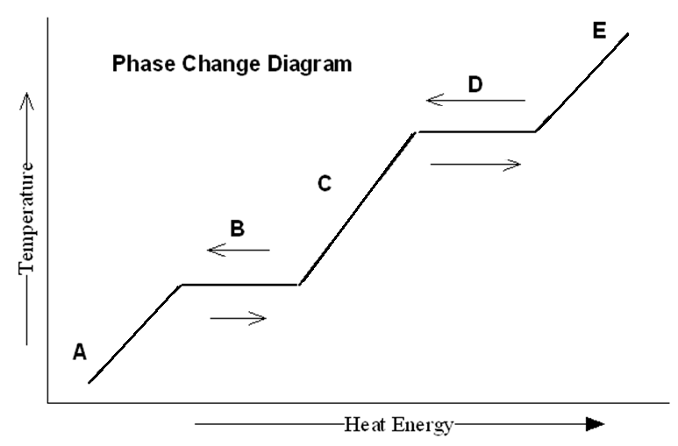
Phase Change Diagrams: HONORS ONLY
      - What is happening at point A?

      - What is happening at point B?

      - What is happening at point C?

      - What is happening at point D?

      - What is happening at point E?

      - What does the horizontal line on the graph represent?

      - At what position on the graph, (and it might not be a letter) is the substance FINALLY completely a liquid?

      - If this graph was representing water, what is the temperature at point B?

      - If this graph was representing water, what is the temperature at point D?

States of Matter Game!
Match each card with the correct column.

Item | Solid | Liquid | Gas
1
2
3
4
5
6
7
8
9
10

