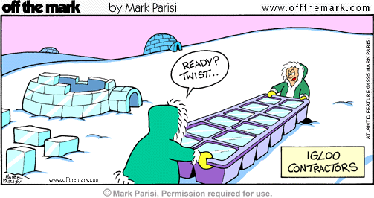
Scientific Method Practice
For each of the examples below, find the independent variable, dependent variable, control(s), and constants.
1. Bailey wants to find out which frozen solid melts the fastest: soda, Gatorade, or orange juice. She pours each of the three liquids into the empty cubes of an ice tray, along with a fourth liquid, plain water. She then places the ice tray in the freezer over night. The next day, she pulls the ice tray out and sets each cube on its own plate. She then waits and watches for them to melt. When the last part of the frozen liquid melts, she records the time.
Independent Variable:
Dependent Variable:
Control(s):
Constants:

2. Jack wants to find out which laundry detergent cleans the best. So, he takes a cotton sheet and cuts it up into equal squares. He stains four squares with chocolate. He washes one of each of the squares in each of the 3 detergents, and the final square is washed in plain water. For each wash load, he used: the same amount of water, the same amount of detergent, and the same temperature of water.
Independent Variable:
Dependent Variable:
Control(s):
Constants:

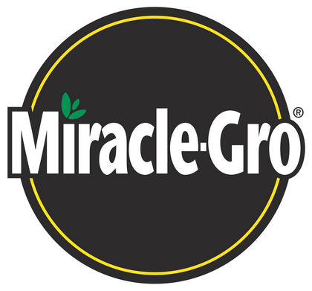
3. Maverick wants to find out whether or not Miracle Grow really makes plants grow faster. He takes two identical pots, puts ½ cup of dirt into each one, puts 3 pea plant seeds into each one, and tops each off with ½ cup more dirt. He waters the plants the same amount at the same time each day. The only difference is that one plant is watered with regular water, while the other is watered with water that has Miracle Grow in it.
Independent Variable:
Dependent Variable:
Controls(s):
Constants:

4. You are conducting an experiment to determine if increased ultraviolet radiation from the decrease in the ozone layer is killing off frog tadpoles. After examining all of the data available in the library, you decide to go with a hypothesis that increased ultraviolet radiation from the sun is killing off the tadpoles.

You design an experiment with a control and an experimental group. Your control group (group 1) involves 100 tadpoles in a five gallon container of water, which is covered by glass (knowing that the glass will filter out the ultraviolet radiation). The experimental group (group 2) will be set up exactly like group 1, except that instead of being covered with glass, it is covered with a plastic, which will not filter out the U.V. radiation. You then place the groups outside for a period of a month. The tadpoles are provided food daily. Observe the results.

Results

 | Group 1 (control) | Group 2 (exp.)
Number of Tadpoles started with | 100 | 100
Number of Tadpoles finished | 96 | 96

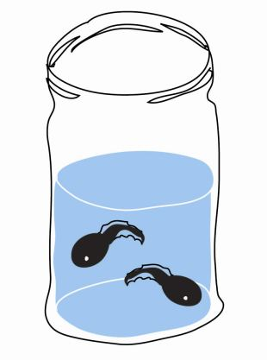
Using this information, answer the following questions.

a. What is the independent variable and what is the dependant variable?

b. Does the information from this experiment support the hypothesis?

c. Which is the control group, and which is the experimental group?

d. What is the difference between the two groups? Should they be different in any other way?

