Bohr Model Diagrams

For each element, write the total number of electrons on the line. Fill the orbit closest to the nucleus first, but never exceed the number each orbit can hold. Check the Periodic Table to find out how many electrons each element actually has.

Before you start:
- How many electrons can the first orbital hold?
- How many electrons can the second orbital hold?
- How many electrons can the third orbital hold?
- How many electrons can the fourth orbital hold?
- What does each orbital or shell actually represent?

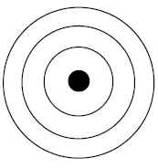
Sodium (Na) | Hydrogen (H) | Carbon (C)
Has ____________ electrons | Has ____________ electrons | Has ____________ electrons
Silicon (Si) | Oxygen (O) | Chlorine (Cl)
Has ____________ electrons | Has ____________ electrons | Has ____________ electrons
Neon (Ne) | Helium (He) | Fluorine (F)
Has ____________ electrons | Has ____________ electrons | Has ____________ electrons
Now draw your own Bohr Models for the following atoms:
Lithium (Li) | Sulfur (S) | Argon (Ar)
Has ____________ electrons | Has ____________ electrons | Has ____________ electrons

