Conservation of Energy

1 | 2 | 3 | 4
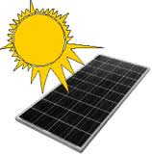 |  | 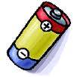 | 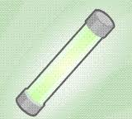
Solar Cell | Wind Turbine / Generator | Battery | Glow Stick
5 | 6 | 7 | 8
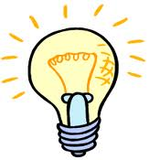 | 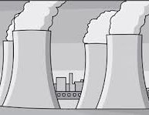 | 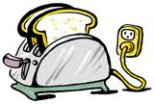 | 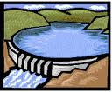
Light Bulb | Nuclear Reactor / Power Plant | Toaster | Hydroelectric Dam / Power Plant
9 | 10 | 11 | 12
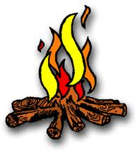 | 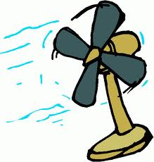 | 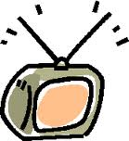 | 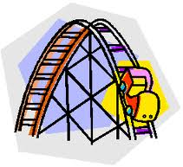
Campfire | Electric Fan | Television Set | Roller Coaster  (Top of 1st hill)

Item | Energy Started With | Energy Ending With
 |  | Desired Energy | “Waste Energy”
- Solar Cell
- Wind Turbine / Generator
- Battery
- Glow Stick
- Light Bulb
- Nuclear Reactor / Power Plant
- Toaster
- Hydroelectric Dam / Power Plant
- Campfire
- Electric Fan
- Television Set
- A roller coaster cart starting at the top of the 1st hill and traveling downhill

