Unit 2: Extra Practice

I. Basic Atomic Structure:
I will give you information in the column on the left. You tell me if that information deals with the proton, neutron, or electron. Just write YES if it deals with that particle. The top 2 are done as examples…

 | Proton | Neutron | Electron
Has a positive charge | YES
Makes up the 99.99999% of the mass of an atom | YES | YES
Organized into shells or orbitals
Found in the nucleus
Defines the element
Has a negative charge
Changing the number of these means that we are dealing with isotopes
Mass of 1 AMU
Changing the number of these gives the atom a positive or negative charge
Found in the electron cloud
Has no charge
Equal to the number of protons in a NEUTRAL atom
These plus protons provide you the atomic mass of an atom
Travel in orbits around the nucleus
Travel in orbitals around the nucleus

II. Isotopes and Ions
Fill in the blanks on the image….

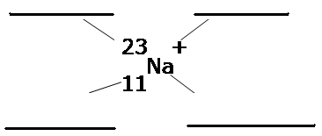

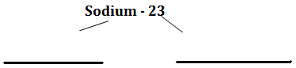

III. Models:
Element | Symbol | # of electrons | # of VALENCE electrons | Lewis Dot | Bohr Model
Magnesium

Sulfur

Boron

Argon

Nitrogen

VI. Atomic Particle Charts – Fill in the table below
Substance | Symbol | Atomic Number | Mass Number | Number of Protons | Number of Neutrons | Number of Electrons | Neutral atom, cation, or anion | Write the Isotope/Ion Notation
Aluminum - 27 | Al⁻¹ | 13 | 27 | 13 | 14 | 14 | -1 anion | ₁₃²⁷Al⁻¹
Iodine - 125 |  |  |  |  |  | 54
 |  | 15 |  |  | 16
 | Ar |  | 40 |  |  |  | Neutral
 |  |  |  |  |  |  |  | ₁₉³⁹ K ⁺¹
 |  |  |  | 28 | 31
 |  | 4 | 9
Magnesium - 26
 |  |  |  |  |  | 18 | +2 cation
Substance | Symbol | Atomic Number | Mass Number | Number of Protons | Number of Neutrons | Number of Electrons | Neutral atom, cation, or anion | Write the Isotope/Ion Notation

HONORS ONLY:

 | Electron Configuration | Orbital Diagram | Unpaired Electrons
He |  | 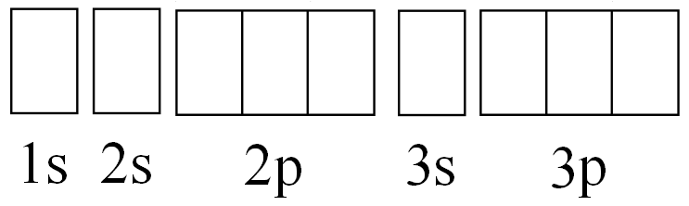
Li
C
Na
P
Ca |  | Don’t worry about this… | Don’t worry about this…
Br |  | Don’t worry about this… | Don’t worry about this…
Ba |  | Don’t worry about this… | Don’t worry about this…

