Unit 6 – Extra Practice

PART 1: CONCEPTS
- What is viscosity?

- I am going to eat some pancakes for breakfast this weekend. If I warm up some maple syrup before I pour it on the pancakes, have I increased or decreased the viscosity of the maple syrup?

- Frank walks 8 meters east, and then 5 meters west.
  - What is Frank’s total distance traveled?

  - What is Frank’s total displacement traveled?

- What is the difference between speed and velocity?

- Give me 1 example of average speed.

- Give me 1 example of instantaneous speed.

- What is a singular word that indicates that your velocity is increasing?

- What is a singular word that indicates that your velocity is decreasing?

- Acceleration due to Gravity on Earth =

- Gravitational force between 2 objects depends on what 2 things?

PART 2: CALCULATIONS
- A train is traveling at 745 km/hr travels the 613 km from Los Angles to Sacramento. How much time will it take to make that trip on this super fast train?

- A tiger is crouching, silently and motionless in the tall grass. He finally pounces forward, accelerating for 3.5 seconds after its prey, reaching a final velocity of 15.7 m/s. What was the acceleration of our tiger?

- What is the velocity of a rhino that runs 48 meters in 6.7 seconds?

- If a golf ball is hit and accelerates at 17m/s² until it reaches a final velocity of 58 m/s, how much time did it take the golf ball reach this final velocity?

- How far is a ball thrown, if it travels at 8.9m/s and takes 2.5 seconds to reach the recipient?

- If a ball, dropped from rest, falls for 3 seconds, what is the final velocity of that ball?

PART 3: GRAPHS
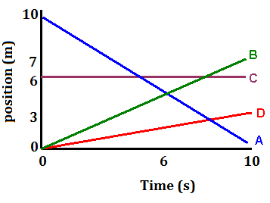
Using the position vs time graph to the right, answer the following questions:
- What does the slope of a straight line on a position vs time graph indicate?

- Describe what each line segment is indicating in terms of motion.
  - ________________________________________________________________
  - _______________________________________________________________
  - _______________________________________________________________
  - _______________________________________________________________
- Which line segments indicate the fastest motion?

- Calculate the average velocity of the Line B.

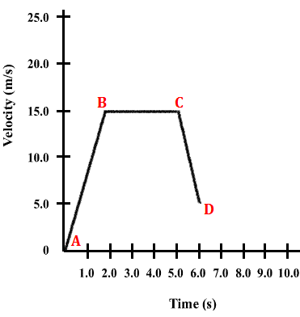
Using the velocity vs time graph to the right, answer the following questions:
What does the slope of a straight line on a velocity vs time graph indicate?

- Describe what each line segment is indicating in terms of motion.

A to B - _______________________________________________________________
B to C - _______________________________________________________________
C to D - _______________________________________________________________
- Calculate the average acceleration from A to B.

PART 4: SCALAR VS VECTOR
Tell me if the following applies to scalars or vectors:
- A tennis ball is thrown 11m north towards a wall. It hits that wall and bounces off of it, traveling 17 meters back south. What is the final displacement of that tennis ball?

- Jason decides to go for a drive. He drives his car 8 miles south for 10 minutes, then turns around and drives 11 miles north for another 15 minutes. Draw the vectors (head to tail) and calculate the resultant vector’s displacement.

 | Scalar | Vector
Characterized by magnitude only
Characterized by magnitude and direction
Distance
Velocity
8m/s
Speed
Displacement
4m east
3 miles south
55 km/hr

PART 5: HONORS ADDITIONS
- It is “run the bases night” at the Riverdogs game if you are 12 years old or younger. You watch your 5 year old cousin run north from home plate to 1st base. The distance between those two bases is 27.43 meters. Being a 5 year old, when your cousin reaches 1st base, she hops on the bag once, and then turns at a right angle towards 2nd base and runs the 27.43 meters west to 2nd base. Draw the vectors (head to tail) and calculate the resultant vector’s displacement of your little cousin’s run from home plate to 2nd base.

- I am watching a game show where contestants try to run through an obstacle course. If they are successful, they win money. This ambitious contestant is running along a balance beam. He runs 12 meters east in 4.7 seconds. Out of nowhere, he is hit by a giant swinging padded ball that is the size of a small car. This knocks our contestant, mid-run off of the balance beam and flies directly north (at a very convenient right angle) 3.2 meters into a foam pit. That unexpected 3.2 meter trip took 1.5 seconds, and cost our contestant a chance at the grand prize. Calculate and draw the velocity vectors (head to tail) and calculate the resultant velocity vector.

- What is momentum?

- What affects the momentum of an object?

- What is the velocity of a 187kg bear that is running with a momentum of 457kg*m/s?

- A 6kg bowling ball is traveling down the lane with a velocity of 11m/s. The bowling ball hits a 4.5kg bowling pin, knocking it backwards sharply. If the bowling ball stops instantly upon impact, in our perfect physics world and conditions, with what velocity did the bowling pin fly backwards?

- A group of boys are bored and put a 2 kg rock up on the top of a fence. They then take turns trying to hit it with a 0.85 kg tennis ball. The 3rd boy hits the rock with a tennis ball throw where the ball is traveling at 7.6 m/s. What is going to be the momentum of the rock when it flies backwards, assuming the tennis ball stops on impact and we have perfect physics conditions?

