Unit 7: Extra Practice

NEWTON’S LAWS
Identify which of Newton’s 3 laws each scenario relates to…
 | 1st Law | 2nd Law | 3rd Law
An object at rest will remain at rest until it is acted upon by an outside force. Similarly, an object in motion will stay in motion until acted upon by an outside force. | YES
Inertia
When a rifle is fired, a bullet flies forward and the gun “kicks” or recoils backwards
If pushed with the same force, a golf ball will accelerate at a greater rate than a bowling ball would
If you are riding a bicycle, and unknowingly ride directly into a bench, the bike will stop and you will fly forward over the handlebars.
A 2kg pillow is thrown through the air with an acceleration of 8m/s². What is the force applied to that pillow?
If you jump off of a surfboard or a raft, you will fly forwards, while the surfboard/raft will float backwards, in the opposite direction of your jump.
You science textbook will remain on your desk, unmoved and collecting dust, until acted upon by an outside force
For every action, there is an equal and opposite reaction.
If you and a friend are riding in a golf cart, and the driver takes a sudden, sharp left, the person in the passenger seat will be thrown out the right “door.”
Force = Mass * Acceleration

CONCEPTS:
For the following questions, we are going to compare dropping a feather and dropping a baseball, at the same time from a height of 2 meters.
- What would be gravitational force that would act on each object? I want you to provide me with the NUMBER.
  - Feather:_________________________
  - Baseball:________________________

- What 2 things influence the gravitational force acting on the baseball and the earth?
  - 1)____________________________
  - 2)____________________________

- When dropped at the same time, which of these objects will hit the ground first?

- Why did that object hit the ground first?

- Is there a scenario that we could create that would allow both to hit the ground at the same time?

MASS AND WEIGHT
 | MASS | WEIGHT
Remains the same everywhere: different elevations, different countries, different planets…
Changes based on gravitational pull at that given location.
Units of grams or kilograms
The measurement of the pull of gravity on an object
The measure of the amount of material inside of an object
Units of newtons

CALCULATIONS
Step One: Write the equation. Step Two: Plug in values Step Three: Solve problem with correct units

- A 2kg pillow is thrown through the air with an acceleration of 8m/s². What is the force applied to that pillow?

- What is the weight of a child that has a mass of 25kg, assuming this child is on Earth?

- If a bird flies 85 meters while chasing her dinner, and covers that distance in 4.9 seconds, then what is the velocity of that flying bird?

- A 3kg book is suddenly teleported to the moon, where there is 1/6 the gravitational pull compared to Earth. What is the weight of this book on mars?

- I kick a soccer ball with a force of 135 newtons. If the soccer ball accelerated at 6.5m/s², what is the mass of that soccer ball?

- What is the mass of a small robot on Mars, when Mars has 1/3 the gravitational pull compared to Earth, if that robot has a mass of 48kg on Earth?

- I hit a baseball off of a tee. If the baseball travels for 3 seconds, and reaches a final velocity of 24m/s, what was the acceleration of that baseball that I hit?

- What is the mass of a 38 newton chair on Earth?

HONORS ONLY

Multiple Equation Problems…
- A rocket is launched. The launch takes 3.8 seconds, and at that point the rocket has a final velocity of 26 m/s. If the rocket has a mass of 2.4 kilograms, what was the force applied to the rocket upon launch?

- I toss a Nalgene bottle to one of my friends. If that bottle has a volume of 1100 ml, and a density of 2.3 g/ml, then what is momentum that the bottle is thrown with assuming I tossed it 2 meters in a time of 3.8 seconds.

- An empty can is sitting on the ground. A child kicks that can, which reaches a final velocity of 7.8m/s. The can has a volume of 355 ml, and a density of 8.1 g/ml, and was kicked with a force of 14 newtons. How long did the can move for before it reached that final velocity of 7.8m/s?

Free Body Diagrams
- If the gravitational force being applied to one of these boxes is 8N, then what must be the normal force applied by the table (assuming the table doesn’t break)?

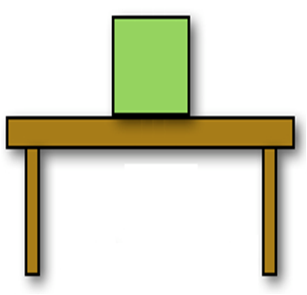
- Draw the arrows necessary for the box to accelerate with an unbalanced force of 8N to the right. Assume that the normal force of the table is 6N, and the friction force between the table and the box is 4N.

- Assume that the force of gravity is 8N, and the friction force between the table and the box is 5N. Draw the arrows necessary for the normal force. AND, draw a push force that is the maximum possible push from the left that would NOT cause an acceleration because of unbalanced forces.

