Acceleration and Acceleration Graphs

General Concepts

- Define acceleration:

- List the 3 things that can cause a change in acceleration AND give me an example of each:
  - 1st thing: ______________________ Example:_______________________
  - 2nd thing: ______________________ Example:_______________________
  - 3rd thing: ______________________ Example:_______________________

- A large acceleration (compared to a small one) means that an object is _________________________________________________________

- A negative acceleration means that an object is _________________________________________________________________

- The gravitational force between two objects depends upon: ________________________________ and _______________________________

  - As ____________________________________ increases, so does the gravitational force

  - As ____________________________________ decreases, the gravitational force increases

- If a graph is showing a positive slope, and the graph itself is a straight line, what must be the x and y axis if the straight line is showing a constant velocity?

- If a graph is showing a positive slope, and the graph itself is a straight line, what must be the x and y axis if the straight line is showing a constant acceleration?

- Multiple Choice: (Only 1 option is correct) A ball is thrown straight up in the air. Which of the following correctly explains what happens as the ball travels upward?
  - Acceleration is negative and velocity is negative.
  - Acceleration is negative and velocity is positive.
  - Acceleration is zero and velocity is positive.
  - Acceleration is zero and velocity is negative.

- Which of the following examples describe a ball experiencing positive acceleration?
  - A ball rolling down a ramp (Circle one: YES or NO)
  - A ball being dropped straight down (Circle one: YES or NO)
  - A ball rolling up a steep ramp (Circle one: YES or NO)

Reading Graphs and Calculations

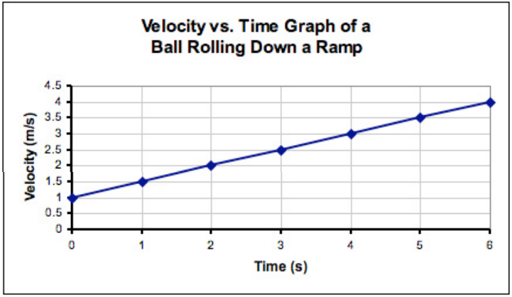
- What is the average acceleration of the ball in the graph to the left? (Show your work)

Using the graph to the right, answer the following:
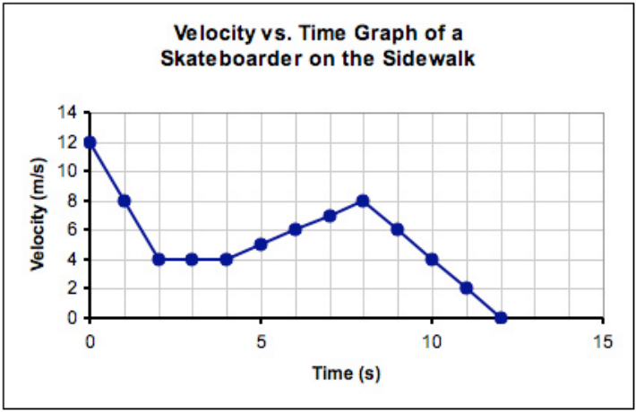
- During which time interval is the skateboarder experiencing constant velocity? (ex: from 10s to 15s)

- During which time interval is the skateboarder experiencing constant acceleration? (ex: from 10s to 15s)

- During which time interval is the skateboarder experiencing constant deceleration? (ex: from 10s to 15s)

- Calculate the acceleration that is occurring between 4 seconds and 8 seconds. Show your work!

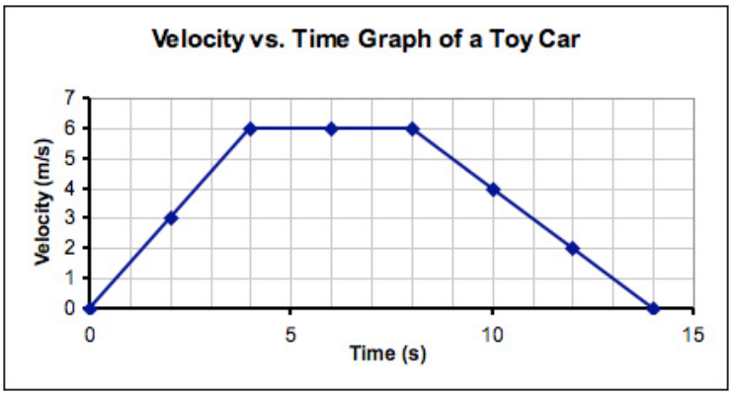
- Which of single the following statements describe the motion shown on the graph to the right?
  - moving forward, constant speed, slowing down
  - speeding up, constant speed, slowing down
  - moving forward, stopped, moving backward
  - speeding up, stopped, moving backward

- What is the net change in velocity for the toy car from 0s to 4 seconds on the graph to the right??

