**GRAPHING: Position vs Time Practice**

**Examine the below graph carefully to answer the next THREE questions.**

1. 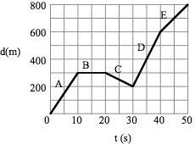What is happening on each of the following segments?

            (a)                       (b)

            (c)                      (d)

            (e)

1. What is the displacement of the truck from its starting point after:

(a)        10 s                        (b)       15 s

(c)        30 s                        (d)       40 s

(e)        50 s

1. What is the truck’s velocity in each of the intervals **A** through **E**? (Show all your work)

**A              _____    C             _____     E             _____**

**B               _____         D             _____**

**Interpreting Graphs:**

Describe the motion that is taking place in each of the displacement *vs*. time graphs. You should probably be telling me what is happening for each straight line segment on the graph (if there are straight lines).

**A B C D E**

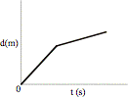 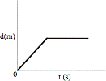  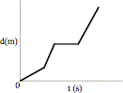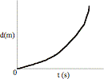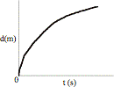

1. **_____________________________________________________________________________________________________________**
2. **____________________________________________________________________________________________________________**
3. **______________________________________________________________________________________________________________**
4. **_____________________________________________________________________________________________________________**
5. **____________________________________________________________________________________________________________**

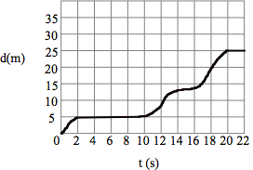**Use this graph to answer the next set of questions.**

1. From the graph above, calculate the average velocity for the entire 22 s.

Equation: Insert givens into equation: Solve:

Find the average velocity for 0s to 2s

Equation: Insert givens into equation: Solve:

Find the average velocity for 4s to 8s

Equation: Insert givens into equation: Solve:

Find the average velocity for 14s to 18s

Equation: Insert givens into equation: Solve: