NAME: ____________________
Energy Conversion Lab
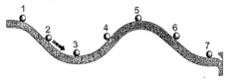
In this lab, you will:
Describe how energy is conserved on a roller coaster.

Hypothesis:
At what single point do you think the marble will move with the greatest kinetic energy when traveling along the track? Why do you think that?
___________________________________________________________

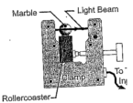
_________________________________________________________________________
Measuring the speed of the marble:
Set the ramp up so that it is connected to the colored stand at the 7th opening. To understand what happens to the marble, you need to measure the speed at the different places on the roller coaster.
  - To measure the speed of the marble, attach the photogate at Position 1, so that the marble breaks the light beam as it rolls through.
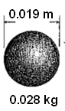
  - Ensure that the photogate is properly set up (set to CPO, cable firmly attached to photogate and A, the light under A is illuminated.

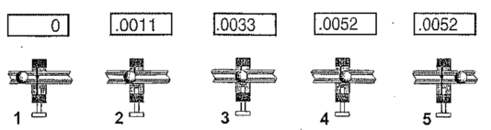
Speed is the distance traveled divided by time taken to travel that distance. During the time that the timer is counting, the marble moves one diameter. Therefore, the distance traveled is the diameter of the marble, and the time taken is the time from photogate A. The speed of the marble is the diameter divided by the time from photogate A.

Methods:
Measure the height from the table to the top of the ramp at the 7 different positions. Next, set up the photogate at position 1, ensuring that the CPO timer is properly set up. Place the marble at the top of the ramp, and release the marble down the ramp. Record the time (all 4 decimals) that appears on the CPO timer into the table below. Repeat this 3 times at each position, so that you have 4 times for each position. If one of the times for a given position does not fit along with the other 3 times, cross it out. Then average the 4 (or 3) times. Use this data to calculate speed, kinetic energy, and gravitational potential energy.

Data Table:

Position  (Distance from Start) (m) | Height from Ground (m)  (round to 100th) | Distance Traveled  (m)  (round to 100th) |  | Time 1:  (seconds)  (show all 4 digits) | Time 2:  (seconds)  (show all 4 digits) | Time 3:  seconds)  (show all 4 digits) | Time 4:  (seconds)  (show all 4 digits) | Average Time  (seconds)  (show all 4 digits) |  | Speed of Marble  (m/sec)  (round to 100th)
.05 m
.25 m
.45 m
.65 m
.85 m
1.05 m
1.25 m

Calculations Table:
Position  (Distance from Start) (m) | Kinetic Energy  ( J )  (show 4 digits after the decimal) | Gravitational Potent Energy  ( J )  (show 4 digits after the decimal) | KE + GPE  ( J )  (show 4 digits after the decimal)
.05 m
.25 m
.45 m
.65 m
.85 m
1.05 m
1.25 m

Graphing and Analyzing Data: Graph the Gravitational Potential Energy vs Position. You should be labeling each data point “1”, “2”, “3”, etc… Connect your data points. You are then going to the Kinetic Energy vs Position. You should be labeling each data point “1”, “2”, “3”, etc… Connect your data points.

THERE WILL BE 2 DIFFERENT LINES ON YOUR GRAPH. Make sure you label which is GPE and which is KE.

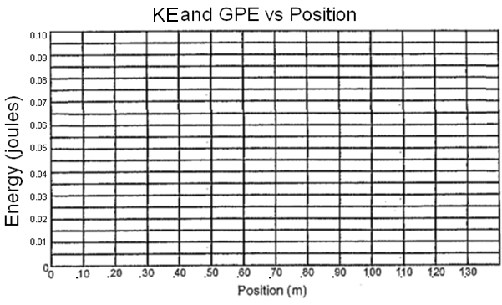

POTENTIAL AND KINETIC ENERGY
Review Questions:
- What is kinetic energy?

- What are the units for kinetic energy?

- What is the equation for kinetic energy?

- Does speed affect kinetic energy? Explain why or why not.

- What is gravitational potential energy?

- What are the units for gravitational potential energy?

- What is the equation for gravitational potential energy?

- Does speed affect gravitational potential energy? Explain why or why not.

Post Lab Questions (Hint: Discussion)
- Did your measurements support your hypothesis or refute your hypothesis? If the data did not support your hypothesis, what sort of hypothesis do the observations support?

- At which point (1, 2, 3, etc) is the speed of the marble the greatest?

- Did any acceleration occur during your lab? Where? Looking at your data, how can you tell?

- Did any deceleration occur during your lab? Where? Looking at your data, how can you tell?

- At which point (1, 2, 3, etc) is the GPE the highest on the ramp?

- Where was GPE the lowest on the ramp?

- At which point (1, 2, 3, etc) is the KE the highest on the ramp?

- Where was KE the lowest on the ramp?

- How are KE and GPE related? Explain why you notice these trends with GPE and KE.

- How is KE related to speed?

- Was there a perfect conversion of energy from KE to GPE and from GPE to KE? What specific data let you know that there was not a perfect conversion of energy?

- Knowing there was not a perfect conversion of energy with the marble on the ramp, what happened to the other energy?

- Describe the flow of energy between potential energy and kinetic energy of the marble along the ramp. Your answer should indicate where the potential energy is greatest and where it is the least. It should also indicate where kinetic is the greatest and where it is the least.

