Name:__________________________________
Investigation of Paper Towel Brand Absorption

Problem:
Is one brand of paper towel really more absorbent than another?

Hypothesis:
IF______________________________________________________________________________________,

Then___________________________________________________________________________________.

Materials:
- Three different brands of paper towels (A, B, C)
- 250ml beaker
- 100ml graduated cylinder with water
- Stopwatch, or cell phone timer
- Metric ruler
- Tong

Procedure: ONLY USE ONE BRAND (A, B, or C) AT A TIME!
- Obtain one square of Brand A paper towel. Measure EXACTLY 10cm X 10cm square on the paper towel and cut it to this size. (Try to set it up so that at least 3 squares can be cut out of each paper towel. This might be achieved by folding the paper towel.)
- Measure EXACTLY 100mL of water into the graduated cylinder. Record this value in the data table.
- Add this water to the beaker.
- Push one square of Brand A paper into the beaker with the 100mL of water and use the tongs to keep it submerged for exactly 30 seconds.
- Slowly remove the paper towel with the pair of tongs and let the paper towel drip over the beaker.
  - When the paper towel drips ONLY 3 TIMES WITHIN 15 SECONDS, place the paper towel into the WASTE beaker.
- Pour the water from the beaker back into the graduated cylinder. Measure the final volume. Record this value in the data table.
- Repeat STEPS 1 - 6 TWO more times for Brand A paper towels and record your results.
- Repeat STEPS 1 - 7 for Brands B and C, performing each procedure THREE times for each brand of paper towel. Record all results.

DATA TABLE:
When all 9 trials have been completed and the average absorbance for each brand has been calculated, enter the data into the class MS Excel spreadsheet at the front of the room. This will be used to calculate a CLASS AVERAGE.

Data Table for each group
 | Brand A  (Absorbance in mL) | Brand B  (Absorbance in mL) | Brand C  (Absorbance in mL)
Qualititative  Observations  (at least 2 of them) | 1)  2) | 1)  2) | 1)  2)
Trial 1 | --  = | --  = | --  =
Trial 2 | --  = | --  = | --  =
Trial 3 | --  = | --  = | --  =
Average

Data Table for the class
Avg. Absorption (ml) | Group 1 | Group 2 | Group 3 | Group 4 | Group 5 | Group 6 | Group 7 | Group 8 | Group 9 | Group 10 | Class Average  (ml)
Brand A
Brand B
Brand C

GRAPH CONSTRUCTION:
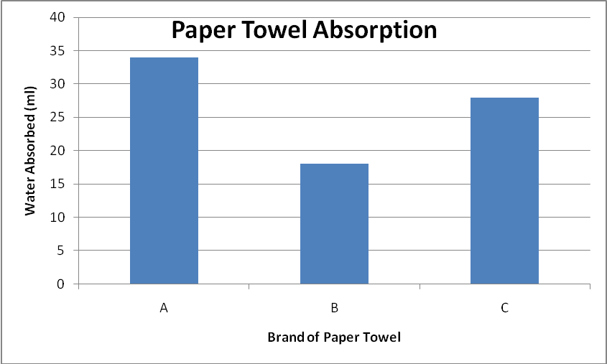
Construct a bar graph to display the results of your experiment.
The bar graph must be constructed according to the following criteria: See Diagram to the right for example.

- The graph should take up AT LEAST 75% of the graph paper
- There must be a title included for your graph
- The vertical axis must be the dependent variable
- The horizontal axis must be the independent variable
- Each axis must be clearly and neatly scaled and labeled
- Each bar must be at least 1 cm wide
- There must be at least 1 cm between bars
- Bars must be shaded a different color
- Include both YOUR DATA and THE CLASS AVERAGE for each paper towel type.

QUESTIONS / CONCLUSION:
- What was the independent variable?

- What was the dependant variable?

- Identify at least 3 constants for this experiment. Lab equipment doesn’t apply (example, do not state the “same beaker” or “same stopwatch”).

- Describe at least 3 ways that some of the towels differ from one another. Consider thickness, “feel”, and whether or not it is “quilted.”

- How could this experiment be improved? Suggest at least two ways.

- Consider the class average, how many TOTAL trails were done for each paper towel type?

- Consider the class average. Did the data your group collected agree with the class average?

- Identify the qualitative and quantitative data collected for this experiment.

- So, considering it was the purpose of the lab, what was the most absorptive towel?

ALTERNATE ASSIGNMENT
Page 7 – Start with Scientific Method
- 7 – Scientific Methods
- 8 – Stating a Problem
  - Researching and Gathering Information
  - Forming a Hypothesis
  - Testing a Hypothesis
- 9 - Variables
  - Constants and Controls
- 10 – Analyzing the Data
  - Drawing Conclusions
  - Being Objective

