Name: ______________________
SPEED LAB
One Photogate To Rule Them All

Question: Can you predict the speed of the car at any point on the ramp?

Review Questions:
- What is speed?

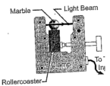
- What is the equation or triangle for speed?

- What is the difference between speed and velocity?

Photogate set up; Measuring the speed:
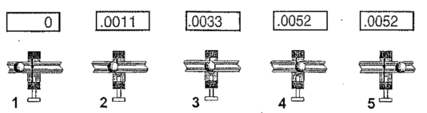
To understand what happens to the cart, you need to measure the speed at the different places on the roller coaster.
- Make sure that the photogate is plugged into “slot A”, the CPO timer is plugged in, and each of the connections are secure.
- Turn on the CPO timer. Make sure that the “interval” setting has a green light lit up under it. Make sure that “A” has a green light lit up above it.

Speed is the distance traveled divided by time taken to travel that distance. During the time that the timer is counting, the cart wing is the distance traveled. The speed of the cart is the length of the cart wing (5 cm) divided by the time from photogate A.

Procedure:
- Select 6 locations along the ramp to measure the speed of the car. The locations should be 30cm, 40cm, 50cm, 60cm, 70cm, and 80cm. Attach the photogate with the screw pointing upward toward the ceiling.
- At each location, record the position of the photogate and the time through the light beam in the table. The distance traveled by the car will be the same for every position since it is the width of the wing (5cm).
- Calculate and record the speed of the care using the car wing width (5cm) and the average time measurement.

Data Table:
Position of the Photogate (cm) from the top of the ramp | Time shown on Photogate after car passes |  |  |  | Distance traveled by car (cm)  Wing width (5.0 cm) | Speed of the Car  (cm / sec)
 | Trial 1  (s) | Trial 2  (s) | Trial 3  (s) | Average Time  (s)
GRAPHING: Graph the speed vs position using a line graph. Place speed of the car on the y- axis, and the position of photogate A on the x-axis. Add labels to each axis and a title to the graph. Your scale should be set up so that the graph covers the entire grid.

Concluding Questions:
- Do you notice a trend in your measurements?

- How does the speed of the car change as it moves down the ramp?

- What does the graph show about the speed of the car?

- Knowing this, you should be able to predict the speed of the car at any random point on the ramp that you DID NOT take a measurement at. So do it. Pick out a random spot and calculate the TIME that the car would be traveling at that point. (Show me your equation, your work, and your answer)

