Name

Making Models of Atoms & Isotopes

Problem: To build 3 – dimensional models of the hydrogen atom.
Re-write the main ideas of the background
information here:

Background Information: An atom is defined as a small particle that makes up most types of matter. Atoms are so small it would take about 1 million of them lined up in a row to equal the thickness of a human hair. Atoms are made up of even smaller particles. The largest of these particles are protons, neutrons and electrons. The identity of a type of matter depends on the number of protons in the nucleus of an atom of that type of matter. All atoms of the same type of matter have the same number of protons in the nucleus. For example, all carbon atoms have six protons.

Not all atoms of the same type of matter have the same number of neutrons. Most carbon atoms have 6 neutrons, although some have more and some have less. Atoms of the same type of matter that have different numbers of neutrons are called isotopes. Most types of matter have isotopes.

The atomic mass, or mass number, can be used to identify isotopes. The mass number of a type of matter is the number of protons and neutrons in one atom of that matter. In our example of carbon, 6 protons + 6 neutrons = 12 particles in the nucleus; the mass number = 12. The name for this isotope is Carbon – 12.
The symbol for Carbon – 12 is:

Mass Number

Atomic Number
12 C
6

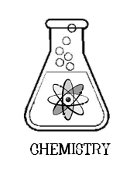
Diagrams of carbon isotopes:
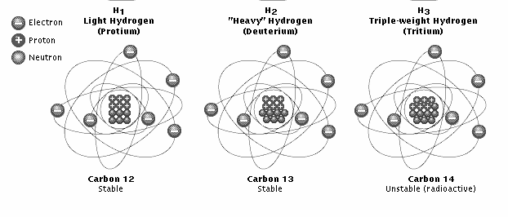

Isotopes are used in many ways. Many are used in cancer therapy. Some are used to help identify the age of objects and locate buried cables.

The gas hydrogen has three isotopes. The most common isotope of hydrogen has a nucleus that is made up of one proton and no neutrons. More than 99% of hydrogen is this isotope. It is sometimes called Protium. A hydrogen atom that has one proton and one neutron in its nucleus is called Deuterium. Deuterium is not radioactive. Water made from deuterium is called heavy water because the extra neutron makes it heavier. It is used in nuclear reactors. The third isotope of hydrogen is known as Tritium. It has one proton and two neutrons in its nucleus. It is radioactive. It is formed in the upper atmosphere by nuclear reactions caused by cosmic rays.
Each isotope of hydrogen has one electron.

Models are often used for things that are too small or too large to be observed or that are too difficult to be understood easily. In the case of atoms, scientists use large models to explain something that is too small to be looked at. Models of the atom are used to explain data or facts that were gathered experimentally.

Materials:
Small colored beads Paper plates Orbitals sheet
Procedure:
- Read the background information, then fill in the chart below:

Isotope | # of Protons | # of Neutrons | # of Electrons
Protium
Deuterium
Tritium

- Pick a color of bead to represent protons:
- Pick a color of bead to represent neutrons:
Teacher initials:
- Pick a color of bead to represent electrons:
- How many protons will you need to make a model of all three isotopes? _____________
- How many neutrons will you need to make a model of all three isotopes _____________
- How many electrons will you need to make a model of all three isotopes? ________
- Have your teacher check and initial your answers.
- Get the correct number & color of beads to make the three isotope models.
10. Make a model of each isotope of hydrogen by placing the beads appropriately on the paper plates.
11. Have your teacher check your models and initial this paper when you are finished.

Models Correct?
Teacher initials:

Data:

Draw a diagram of each model. Show each proton, neutron, and electron. Label the parts. Color the diagram.

 | Protium |  | Deuterium |  | Tritium

Applications & Questions:

- Define isotope:

- Is an isotope an atom? Explain your answer.

- The symbol for one of the isotopes of Uranium is ${}_{92}^{235}U$
How many protons does this atom have?
How many neutrons does this atom have?
How many electrons does this atom have?
What is the mass number of this atom?
What is the atomic number of this atom?

- What is the symbol for the carbon atom that has 6 protons and 8 neutrons?

