Unit 5.1: Motion, Speed, and Velocity
Notes for/from class

Further Reference: 11.1 Observing Motion
MOTION
- Motion is a ______________________relative _______________

  - Frame of Reference is a system used ______________________________

- Distance is _____________________________________

- Displacement is _______________________________________

  - Displacement must always include _____________

- If you run around a 400m track, what is your traveling distance?

- If you run around a 400m track, what is your traveling displacement?

- Scalar is a ___________________________________________________
  - Ex: _________________________

- Vector is ____________________________________________________
  - EX: ___________________________

  - Distance is a ____________________

  - Displacement is a _____________________

VECTOR TERMS
- Part ______________ arrow is the __________ of a vector

- Part ________________ arrow is the ___________ of a vector

- When adding vectors, we always put them _______________________ for as many vectors as we have

- The ________________________ is the result of the vector ____________, and is __________________ drawn from the head of the ____________________ to the tail of the ____________________________

- Vector Addition: Because velocities include magnitude and direction combining 2 different velocities depends on their ___________ and ____________
  - Can occur in __________________________
  - Can occur _____________________________ to each other

  - (HONORS) For vectors at right angles to each other, we use __________________________ to find the ____________________
    - ________ + _________ = __________

Notes for/from class
PRACTICE:
Find the resultant vector when adding 5m north and 22m south.

(HONORS) Find the resultant vector when adding 35km south and 50km west.

SCALAR VS VECTOR
- Scalar (______________________)
  - _____________________________
  - _____________________________

- Vector (____________________AND ______________________)
  - ____________________________
  - ____________________________

SPEED VS VELOCITY
- Speed is _____________________________________________

  - _________________________ includes a direction

- Velocity is ___________________________________________

  - Includes ______________________________________

- Speed = _____________________ / __________________

  - Simply __________________ of velocity

- Velocity = _____________________ / ________________

  - Speed __________________________

VELOCITY Equation
SPEED VELOCITY
Equation in Equation in Equation in Equation in
Words Symbols Words Symbols

- What are the SI units for:
Notes for/from class
  - Velocity (and speed) _________________ (__)

  - Displacement (and distance) _______________(__)

  - Time __________________ (__)

MORE VELOCITY
- Speed has no _________ or _____________

- A vector is a __________________ with a __________________

- By convention, Positive velocity is _______ and _________

- By convention, Negative velocity is ________ and _______

TWO KINDS OF VELOCITY
- Average velocity is ______________________________________

  - What is a real world example?

WE WILL ALMOST ALWAYS CALCULATE AVERAGE SPEED.

- Instantaneous Speed is __________________________________

  - What is a real world example?
Practice Problems Write the equation, Show your work, Include units!
- What is the velocity of a commercial jet which travels from New York City to Los Angeles (4800km) in 6 hours?

- What is the velocity of a bike that travels 355 meters in 103.7 seconds?

- A train travels 100km/hr for 2 hours. What distance has it traveled?

Unit 5.2: Position vs Time Graphs: Guided Fill in Notes

- __________________________ can be studied using a __________________ vs_______________ graph
  - ________________________ is on the vertical axis (it can also be labeled __________________________)
  - ________________________ is on the horizontal axis
- The _________________________ of the line indicates the ______________________ of the object.
- _____________________ can be calculated by finding _____________________________ over ___________________________
So let’s work one out.
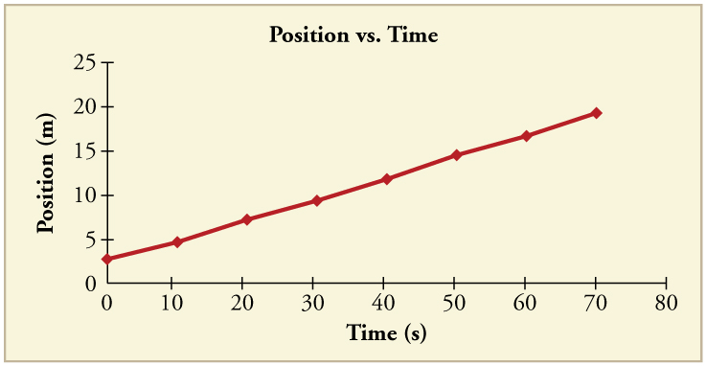
- Choose 2 points: one to start and one to end with
Y₂ = X₂ =
Y₁ = X₁ =
- Calculate the change between the points.
Difference in Position (Y) =
Difference in Time (X) =
- Calculate for Slope = Position / Time

- And remember, SLOPE = _____________________

DIFFE RENT SLOPES MEAN DIFFERENT THINGS
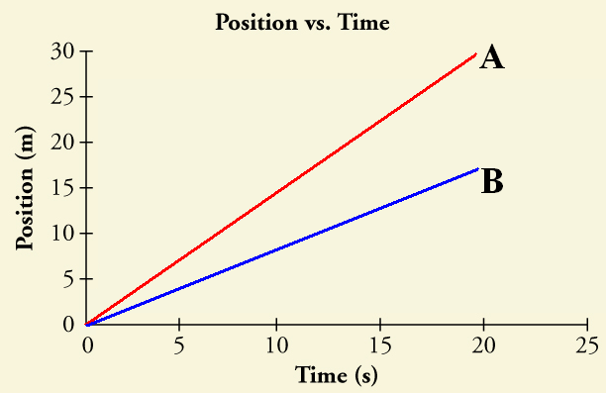
POSITIVE SLOPE:
- A POSITIVE slope indicates a ___________________________
  - Positive velocity means it is ______________________

- The greater the slope, _________________________________
  - The less the slope, ________________________________

- On the graph to the right, which has a greater velocity?
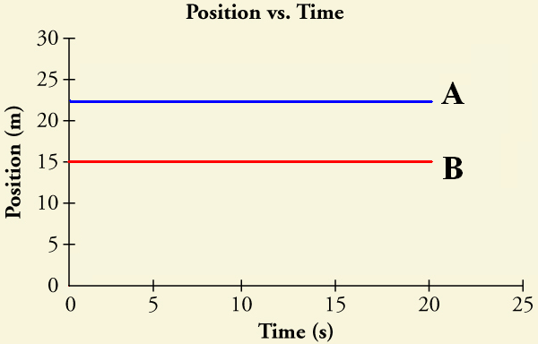
HORIZONTAL (ZERO) SLOPE:
- ZERO slope indicates a ____________________________________
  - ZERO slope means that the line is _________________________________________________
- On the graph to the right, which has a greater velocity?

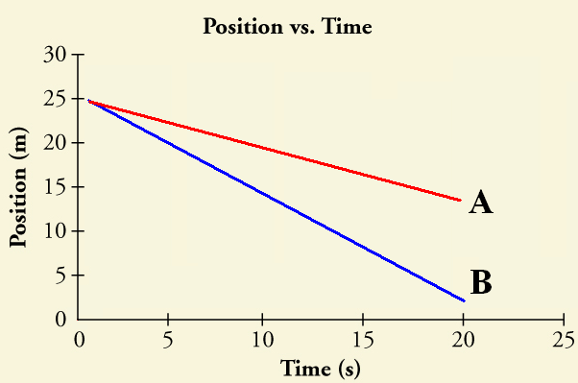
NEGATIVE SLOPE:
- A NEGATIVE slope indicates a __________________________
  - Negative velocity means the object is ________________________________________________
- On the graph to the right, which has a greater negative velocity?

PUTTING IT ALL TOGETHER:
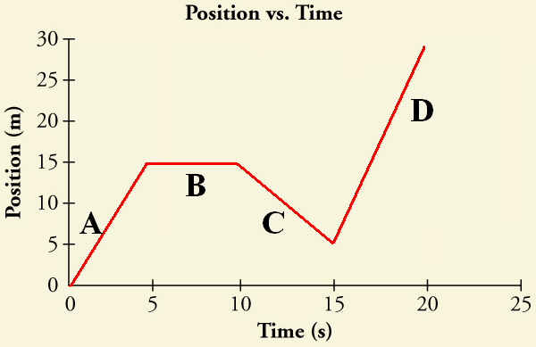
- So what is happening at each of these positions on the graph to the right?
What is happening? Numbers/Units
  - ___________________ ______________________
  - ___________________ ______________________
  - ___________________ ______________________
  - ___________________ ______________________

Unit 5.3: Momentum (HONORS ONLY)
Notes for/from class

Momentum
- Momentum is _______________________________________

  - If an object is _________________, it ____________________

  - An object with _______ of momentum will be _________ to stop

  - An object with _______ of momentum will be _________ to stop

- Momentum equation:
In words In symbols

Words symbols

- The SI unit for momentum is _____________

- Because momentum is based on _____________, the momentum of an object _________________
Practice Problems: Include a formula. Show your work. Include units.
1. Calculate the momentum of a 3kg ball that is moving east at 12m/s.

conservation of Momentum
- Law of Conservation of Momentum is :

  - The total momentum of a system cannot _____________ or _____________

  - The law of conservation of momentum applies anytime ______________________________

- We will always assume perfect physics classroom scenarios for this to work. The 3 assumptions are:
Notes for/from class

  - 1) _____________________________________________________

  - 2) _____________________________________________________

  - 3) _____________________________________________________
Conservation of Momentum Equation:

M₁ = _________________________ M₂ = ______________________________
V₁ = _________________________ V₂ = ______________________________

Practice Problems: Include a formula. Show your work. Include units.
- A 3kg ball is traveling at 8m/s. If it hits an empty bottle, with a mass of 12kg, what will be the velocity that the bottle travels assuming the ball stops on impact and all momentum is transferred?

Unit 5.4: Acceleration and Gravity
Notes for/from class

Further Reference: 11.2 Acceleration and 12.2 Gravity

SCALAR VS VECTOR
- Scalar (______________________)
  - _______________________________
  - _______________________________
  - ________________________________

- Vector (____________________AND ______________________)
  - ____________________________
  - ____________________________
  - ____________________________

Acceleration and Motion
- Acceleration is the ____________________________________

  - A ________________ in _______________ can be caused by:

  - _____________________________
    - Example: __________________________________
  - _____________________________
    - Example: __________________________________
  - _____________________________
    - Example: __________________________________

  - For acceleration to be zero, ______________ cannot be changing

Q1 – If I were to drive around a circular race track at a constant 60km/hr, am I accelerating or not? Explain why.

ACCELERATION EQUATION
In words In symbols

- What are the SI units for:

  - Acceleration______________________ (__)

  - Time _______________________ (__)

  - V_{f} (final velocity) ___________________ (__)

  - V_{i} (initial velocity) __________________ (__)

- If the acceleration is small, the velocity is increasing ___________
Notes for/from class

- If the acceleration is large, the velocity is increasing ___________

- Positive acceleration means an object is ____________________

- Negative acceleration means an object is _________________

  - Negative acceleration is also called ________________
Practice Problems
(write the equation, show your work, include your units)
- You are driving from school home and your velocity goes from 10m/s to 40m/s in 5 seconds. What is your acceleration?

- If a football is thrown from rest with an acceleration of 8.5m/s² and had a final velocity of 25m/s. How long was the football accelerating?

GRAVITY AND ACCELERATION

- Gravity is __________________________________________________

  - Acceleration due to gravity is __________________________

  - A vacuum is a ________________________________________

  - When not in a vacuum, air resistance will _______________ a falling object

Universal Gravitation
- All objects in the universe exert a ___________________ on every other object in the universe.

- The gravitational force of gravity between two objects depends on:

1)___________________: As the _________________
increases, the gravitational force _________________

2)___________________: As the _________________
increases, the gravitational force ________________

Unit 5.5: Velocity vs Time Graphs

- Acceleration is_________________________________________________________________

- The vertical axis (____) will be ___________________________

- The horizontal axis (___) will be _________________________________

- Slope of a Velocity vs Time is equal to _____________________________________________
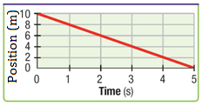
- Does the graph to the right represent velocity or acceleration?

  - How can you tell?

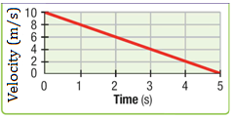
- Does the graph to the right represent velocity or acceleration?

  - How can you tell?

- A velocity vs time graph shows _____________________________________________

- Any slope shows us _______________________________________

DIFFE RENT SLOPES MEAN DIFFERENT THINGS
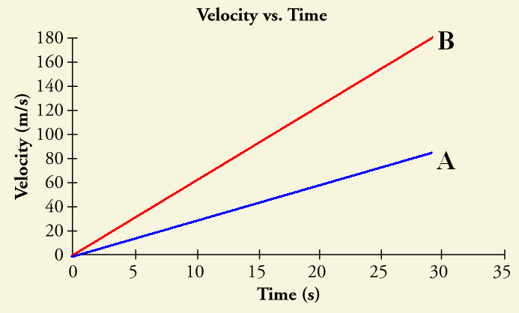
POSITIVE SLOPE:
- A POSITIVE slope indicates a ______________________________
  - Positive acceleration means it is ______________________________________________________
- On the graph to the right, which has a greater acceleration?
NO SLOPE:
- A slope of ZERO indicates a _____________________________________________________
  - This just means that there is a __________________________________________
  - Slope of zero = ______________________________________________________
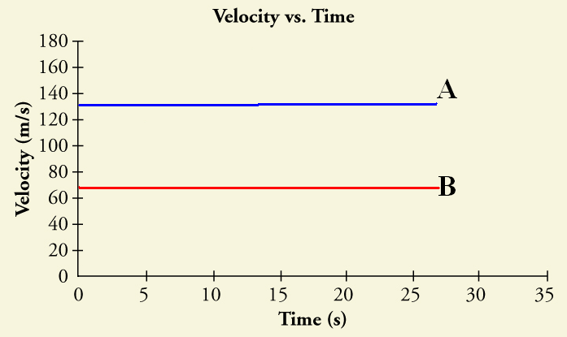
- On the graph to the right, which has a greater acceleration?

- On the graph to the right, which of the two lines have the greater velocity?

NEGATIVE SLOPE:
- A NEGATIVE slope indicates a _____________________________________________________
  - NEGATIVE acceleration means it is ______________________________________________________
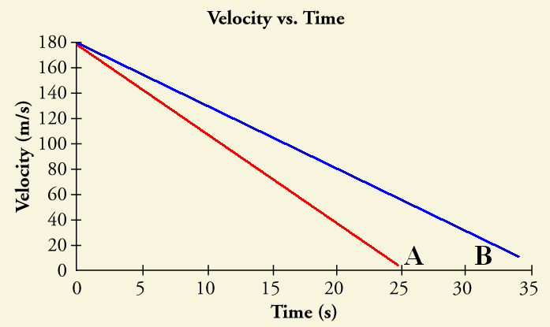
  - Deceleration = __________________________________________________________
- On the graph to the right, which has a greater deceleration?

RECAP
- What does a positive slope indicate? ____________________________________________________

- What does a negative slope indicate? ____________________________________________________

- What does a perfectly horizontal line indicate? _____________________________________________

CALCULATING SLOPE:
- What is the formula for acceleration?

- What is the velocity of the object at 1 second?

- What is the velocity of the object at 4 seconds?

- What is the acceleration of the object between 1 second and 4 seconds?

- What do you notice about the slope and your acceleration?

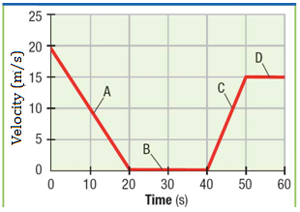
PUTTING IT ALL TOGETHER:
- This is a Velocity vs. Time graph, what does the slope represent?

- What is happening at each of the following line segments?
  - _______________________________
  - _______________________________
  - _______________________________
  - _______________________________

- Calculate the acceleration for each of the following line segments:
Line A) Line B)

Line C) Line D)

