Nuclear Application

 | Fission | Fusion
Explain this process in a quick statement
What is the starting atom?
What HAPPENS to the starting atom to actually start the reaction?
What are the products of the reaction? (What do we end with?)
Does this reaction display a chain reaction?
Sketch me a diagram of what is occurring.

Equations for Fusion and Fission. Solve for the daughter or parent nuclide in each equation. Decide whether the equation represents the process of fission or fusion.

Nuclear Equation | Type of Nuclear Reaction
$${}_{1}^{1}{H + {}_{4}^{7}{Be → _______}}$$

$${}_{92}^{238}{U + {}_{0}^{1}n→ {}_{56}^{141}{Ba + _______}}$$
$${}_{1}^{3}{H + {}_{9}^{17}{F → _______}}$$

Uses of Nuclear Energy:

- What is an example of an uncontrolled nuclear reaction?

- What is an example of a controlled nuclear reaction?

Nuclear Power Plant:
- Explain how a nuclear power plant works in 4 basic steps.

  - ____________________________________________________________________________________________________________

  - ____________________________________________________________________________________________________________

  - ____________________________________________________________________________________________________________

  - ____________________________________________________________________________________________________________

- On the picture below, identify which of the above steps (A, B, C, or D) belongs on each of the blank spaces.
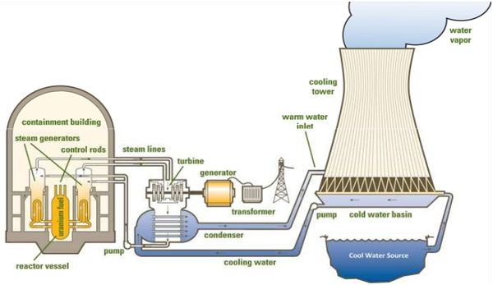

- How do we control the amount of fission occurring within the Reactor Core?

- What is being released from the top of the “smoke stack looking thing”? Is that material dangerous at all?

- Why are the Fuel Rods still dangerous even after we have done all the fission and all we have is Kr and Ba?

