Parallel and Series Circuits: Math Name: ________________________________
1 | 2
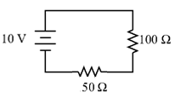 | 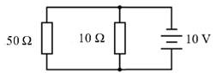
What is the total resistance? | What is the voltage on the 10 ohm branch?
What is the total current? | What is the current on the 50 ohm branch?
What is the voltage drop on the 100 ohm resistor? | What is the current on the 10 ohm branch?
What is the voltage drop on the 50 ohm resistor? | What is the total current of this circuit?
3 | 4
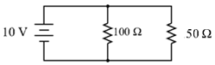 | 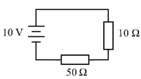
What is the voltage on the 50 ohm branch? | What is the total resistance?
What is the current on the 100 ohm branch? | What is the total current?
What is the current on the 50 ohm branch? | What is the voltage drop on the 10 ohm resistor?
What is the total current of this circuit? | What is the voltage drop on the 50 ohm resistor?

