Parallel and Series Circuits: Identify
(Series and Parallel: What changes, what stays the same)

1 | 2 | 3
Series or Parallel: ____________ | Series or Parallel: ____________ | Series or Parallel: ____________
Voltage Stay Same / Drop? _______ | Voltage Stay Same / Drop? _______ | Voltage Stay Same / Drop? _______
Current Stay Same / Change? _______ | Current Stay Same / Change? _______ | Current Stay Same / Change? _______
4 | 5 | 6
Series or Parallel: ____________ | Series or Parallel: ____________ | Series or Parallel: ____________
Voltage Stay Same / Drop? _______ | Voltage Stay Same / Drop? _______ | Voltage Stay Same / Drop? _______
Current Stay Same / Change? _______ | Current Stay Same / Change? _______ | Current Stay Same / Change? _______
7 | 8 | 9
 |  | 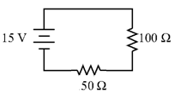
Series or Parallel: ____________ | Series or Parallel: ____________ | Series or Parallel: ____________
Voltage Stay Same / Drop? _______ | Voltage Stay Same / Drop? _______ | Voltage Stay Same / Drop? _______
Current Stay Same / Change? _______ | Current Stay Same / Change? _______ | Current Stay Same / Change? _______
10 | 11 | 12
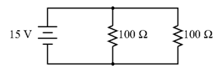 | 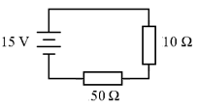 | 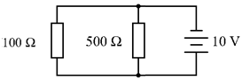
Series or Parallel: ____________ | Series or Parallel: ____________ | Series or Parallel: ____________
Voltage Stay Same / Drop? _______ | Voltage Stay Same / Drop? _______ | Voltage Stay Same / Drop? _______
Current Stay Same / Change? _______ | Current Stay Same / Change? _______ | Current Stay Same / Change? _______

