Name_________________________
PHET: FORCES AND MOTION

NET FORCE
*Click the check boxes in the top right hand corners for “Sum of Forces” and “Values”

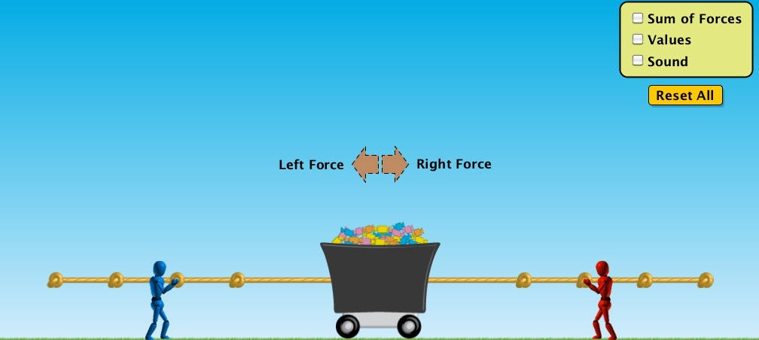 | Predicted Movement | Actual Movement  (none, left, right) | Sum of Forces  (0, x-left, x-right)
TASK 1
1 person on each side: Same size persons, same distance from cart
TASK 2
1 person on each side: Same size persons, different distance from cart
TASK 3
1 person on each side: different size persons, same distance from cart
TASK 4
2+ person on each side: have fun with the set up

Analysis Questions/Reasoning:

- What causes objects to move?

- Give an example of a balanced force.

- Give an example of an unbalanced force.

- True or false? Balanced forces cause a change in motion.
  - How do you know this?

- True or False? Unbalanced forces cause a change in motion.
  - How do you know this?

MOTION
*Click the check boxes in the top right hand corners for “Force”, “Values”, “Masses”, and “Speed”

Play around for a minute.

- What is the skateboard helping us minimize?

- If you apply a force just long enough so that the skateboard and whatever is on it start moving (so that the applied force arrow appears and then disappears) what will happen to the skateboard and the stuff once you stop applying that force? Basically, does the skateboard+stuff continue moving at a constant velocity, accelerate, or slow down and stop? Hint: look at the speed gauge.

- If you apply a continual force to the skateboard and the stuff, what will happen to the pusher, and what will happen to the skateboard and the stuff once you stop applying that force? Hint: look at the speed gauge.

- If we can get the skateboard moving so that it is moving without currently having a force applied to it, what needs to happen to slow down/stop the skateboard?

- Reset what is on the skateboard such that the only three things on it are the little girl, the man with the tie, and the refrigerator. (the order doesn’t matter, but I would put the fridge on top). Push the people on the skateboard with a force of 200N to the right. Calculate the Acceleration of the skateboard+stuff. (show me the equation, your numbers, and your answer with units)

- Reset what is on the skateboard such that the only three things on it are the two wodden crates and the garbage can. (again, order doesn’t matter). Push the skateboard+stuff with a force of 150N to the left. Calculate the Acceleration of the skateboard+stuff. (show me the equation, your numbers, and your answer with units)

FRICTION
Click the friction tab and complete the following questions:

- How much harder was it to cause acceleration now? Why was it harder?

- Once you stop pushing, will the box move forever now? Why or why not?

