Acceleration Post Lab

- A T-Rex hears Jeff Goldblum screaming for help (No idea what I’m talking about? Go watch Jurassic Park. And read a book.) and starts to run at him because Jeff Goldblum looks like a delicious little snack to a T-Rex. If the T-Rex chases starts from rest , runs for 35 seconds, and reaches a final velocity of 6.67m/s, what is the acceleration of the T-Rex? (PS: Jeff Goldblum was not harmed in the making of this question…)

- A 1.8kg tennis ball moving at 12m/s hits a 0.7kg golf ball sitting on a tee. If the tennis ball stops on impact, with what velocity will the golf ball travel off the tee?

- A team of two students is participating in a relay race. From the starting line, individual one runs 250m north towards individual two in 32 seconds. Individual one tags individual two to start, who travels directly SOUTH (90 deg angle) and hops in a potato sack for 45 seconds while traveling 30 meters. Solve for the velocity of each team member, and draw the vectors, and determine what the resultant vector’s velocity is.

- One of my wonderful students happens to be on the baseball team. After a day of not working, being rude, and being disrespectful, I talk to Coach Christopher and he says “I’ll take care of it.” I then hear the next day as he tells me that the student ran 100m north, 200m south, 300m north, 400m south, 500m north, 400m south, 300m north, 200m south, and 100m north.

  - In the above problem, what is the distance covered by my stellar student?

  - In the above problem, what is the displacement covered by my stellar student?

- A group of boys are bored and put a 2 kg rock up on the top of a fence. They then take turns trying to hit it with a 0.85 kg tennis ball. The 3rd boy hits the rock with a tennis ball throw where the ball is traveling at 7.6 m/s. What is going to be the momentum of the rock when it flies backwards, assuming the tennis ball stops on impact and we have perfect physics conditions?

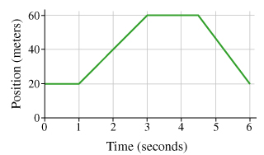
Use the graphs to the right for the following problems.

- What does the slope of the graph to the right represent?

- Tell me what is happening, and calculate the velocity, for each segment:

0 seconds to 1 second  Happening: ___________________ Velocity _______________________  1 second to 3 seconds  Happening: ___________________ Velocity _______________________ | 3 seconds to 4.5 seconds  Happening: ___________________ Velocity _______________________  4.5 seconds to 6 seconds  Happening: ___________________ Velocity _______________________

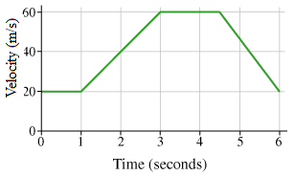
Use the graphs to the right for the following problems.

- What does the slope of the graph to the right represent?

- Tell me what is happening, and calculate the acceleration, for each segment:
0 seconds to 1 second  Happening: ___________________ Acceleration_____________________  1 second to 3 seconds  Happening: ___________________ Acceleration_____________________ | 3 seconds to 4.5 seconds  Happening: ___________________ Acceleration_____________________  4.5 seconds to 6 seconds  Happening: ___________________ Acceleration_____________________

