Speed CPO Lab Day Stuff

Velocity
- A bird is flying north, and it takes 3 seconds to fly 14 meters. What is the velocity of the bird?

- A ball is thrown 8m/s towards a barn. If it takes 2.5 seconds to reach that barn, how far away was the barn?

- A tiger is playing with a mouse. The mouse runs south for 2.4 meters until the tiger swats it directly east 3.5 meters. Draw the vectors head to tail, and solve for the resultant displacement.

Position vs time graphs:
- What does the slope of this graph represent? How do you know?

- What is occuring on line A?

- What is occuring on line B?

- What is occuring on line C?
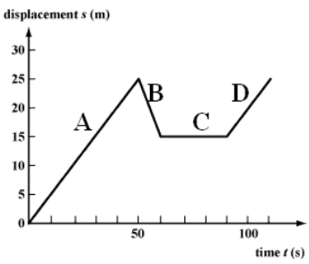

- What is occuring on line D?

- Calculate the velocity of line A.

- Calculate the velocity of line B.

- Calculate the velocity of line C.

