Unit 1 Study Guide

- What is matter?

- List the 3 steps of the Kinetic Theory of Matter / Atomic Theory:

1.__________________________________________________________________________________________________

2. __________________________________________________________________________________________________

3. __________________________________________________________________________________________________

Draw a pictureof what the particles of each state of matter would look like in the container | Volume:  Does this state of matter have a definite Volume? (Definite or Not Definite) | Shape:  Does this state of matter have a definite shape (Definite or Not Definite) | Describe the movement of the particles. (Slow? Fast? How do they move?) | How closely are the particles packed? (Close together? Spread apart?)
Solid:

Liquid:

Gas:

Phase Change | Between what 2 states of matter? | What’s happening to the particles as they change from one state to another? | Example of Phase Change
Condensation
Evaporation
Freezing
Melting
Sublimation
Deposition

Classification of matter:
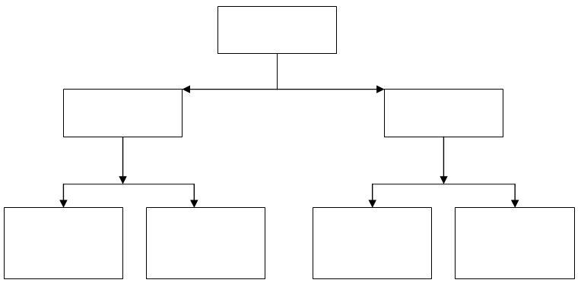

Word Bank: Mixtures, Compounds, Matter, Homogeneous, Element, Substance, Heterogeneous

1. ____________ have only one type of matter and cannot be physically separated

2. ____________ are made up of multiple things and the different parts are easily distinguishable.

3. ____________ are two or more elements chemically bonded together.

4. ____________ are made up of multiple types of matter and are classified based on how thoroughly blended they are.

5. ____________ are defined as having all the atoms exactly the same. Cannot be broken down into smaller parts.

6. ____________ contains multiple types of matter, but they are distributed evenly throughout.

Chemical vs Physical Changes
- What is a physical property?

- What is a physical change?

- What are 3 signs that a physical change occurred?

- What is a chemical property?

- What is a chemical change?

- What are 6 signs that a chemical change occurred?

Tell me if the following is a Physical or Chemical Change:
- Vinegar and baking soda volcano 10. Cutting a steak

- Ice cream melting 11. Burning paper

- Crushing a car at a junk yard 12. Rust forming

Separating Mixtures:
- Do you separate an element by chemical or physical means?

- Do you separate a compound by chemical or physical means?

- Do you separate a heterogenous mixture by chemical or physical means?

- Do you separate a homogenous mixture by chemical or physical means?

- How can you separate salt water into salt and water?

- How can you separate alcohol from water?

HONORS ONLY for the rest of the study guide:
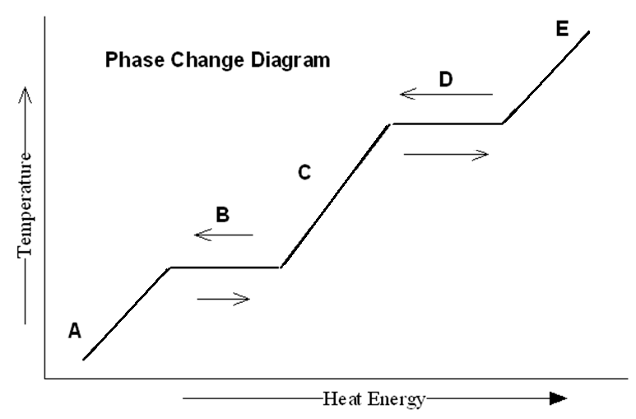
Phase Graph: Use the graph to the right for the following questions:
      - What is happening at point B?

      - What is happening at point C?

      - What is happening at point D?

      - What is happening at point E?

      - What does the horizontal line on the graph represent?

      - When does the substance finally become entirely a liquid when it starts off as a solid?

Gas Laws:
- If I am using Boyles law, what happens to pressure if I decrease the volume?

- If I am using Charles law, what happens to the temperature if I increase the volume?

- A sample of argon gas occupies 0.82 L at 1.34 atm. What will be its volume at 0.84 atm of pressure?
Law being used: ______________ FORMULA WORK ANSWER

Given 1:__________

Given 2:__________

Given 3:__________

- A gas at 277 K occupies a volume of 0.76 L. At what temperature, in Kelvin, will the volume increase to 1.21 L?
Law being used: ______________ FORMULA WORK ANSWER

Given 1:__________

Given 2:__________

Given 3:__________

- If it takes 0.25 L of nitrogen gas kept in a cylinder under pressure to fill an evacuated 3.5 L vessel in which the pressure is 0.8 atm, what was the initial pressure of the gas in the cylinder?
Law being used: ______________ FORMULA WORK ANSWER

Given 1:__________

Given 2:__________

Given 3:__________

