Unit 2 Study Guide
I. Vocabulary
Atomic Mass = ____________________________________________

Atomic Number = __________________________________________

Mass Number = ___________________________________________

Isotopes= ________________________________________________

Ions= ___________________________________________________

Valence Electrons= ___________________________________________________

II. Basic Atomic Structure
 | Charge | Location | Mass
Proton
Neutron
Electron

- Which particle defines the element?

- What charge does the nucleus of an atom normally have?

- What does it mean for an atom to be neutral? (Explain using the words proton, neutron, electron)

- How are the electrons arranged in an atom?

- Knowing that every periodic table is different, how do I tell which one thing is the atomic number?

- Knowing that every periodic table is different, how do I tell which one thing is the atomic mass?

- If you know an elements Atomic number, what else do you know about the element? (Assume the element is neutral)

- How do you get the mass number from the periodic table?

- Electrons do not travel in an orbit. Explain this statement, using the words orbit, orbital, electron cloud, and energy level.

III. Isotopes and Ions
- What do the numbers after the name of an element represent? Ex. Magnesium – 26

- In the example to the right, why don’t I have to include the number of protons before Magnesium? Ex. Magnesium – 26

- Assume you have these 2 elements: ⁵⁵₂₅Mn and ⁵⁶₂₅Mn
  - How are these elements different from each other?

  - What do we call these elements?

  - How would you name each element?

- Use the following information to fill in the chart for these elements:
Element/Isotope Information | Write the Isotope Notation | Name the Element/Isotope
p = 19 , e= 19, n = 20

p=75, e=75, n = 111

p = 18, e = 18, n = 22

- What is a cation?

- Does a cation have a positive or negative charge?

- What is an anion?

- Does an anion have a positive or negative charge?

IV. Lewis Dot –
Element | Symbol and # of Electrons | Lewis Dot | Bohr Model
Potassium

Oxygen

Aluminum

Neon

VI. Miscellaneous – Fill in the table below
Substance | Symbol | Atomic Number | Mass Number | Number of Protons | Number of Neutrons | Number of Electrons | Neutral Atom or Ion | Write the Ion Notation (with charge)
Aluminum | Al⁻¹ |  | 27 | 13 |  | 14 |  | ₁₃²⁷Al⁻¹
Carbon | C | 6 |  |  | 6 |  | Neutral
Sodium | Na⁺¹ |  | 23 |  |  | 10
Tin |  | 50 | 119 | 50 |  | 50
Barium |  | 56 | 138 |  |  | 54 |  | ₅₆¹³⁸Ba²⁺
Iodine | I |  |  | 53 | 76 | 53
Oxygen | O²⁻ |  |  |  | 6 |  | -2 Ion
Magnesium | Mg⁺² |  | 24 | 12 |  |  | +2 Ion | ₁₂²⁴Mg⁺²
Chlorine |  |  |  |  | 20 |  | -1 Ion
Bromine | Br | 35 |  | 35 | 40 |  | Neutral

HONORS ONLY:

 | Electron Configuration | Orbital Diagram | Unpaired Electrons
H |  | 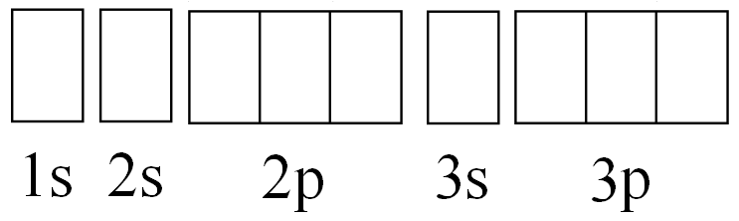
Be
N
S
Cl
F
Al
Se |  | XXXXXXXXXXXXXXXXXXXX XXXXXXXXXXXXXXXXXXXX XXXXXXXXXXXXXXXXXXXX XXXXXXXXXXXXXXXXXXXX XXXXXXXXXXXXXXXXXXXX | Xxxxxxxxxxxxxxxxxxxx xxxxxxxxxxxxxxxxxxxx xxxxxxxxxxxxxxxxxxxx xxxxxxxxxxxxxxxxxxxx xxxxxxxxxxxxxxxxxxxx xxxxxxxxxxxxxxxxxxxx

