Unit 8 - Electricity Study Guide

- Describe the interactions between the following two charges:
  - Like charges will _____________

  - Opposite charges will _____________

- Explain what current is.

- Explain what resistance is.

- Explain what voltage is.

- Explain what voltage drop is.

- Which type of circuits experience voltage drop?

- Current flows in what direction?

- Explain why current flows in that direction. (Hint, you should be explaining the movement of electrons)

- Explain what an insulator is and give me 2 examples of insulators.

- Explain what a conductor is a give me 2 examples of conductors.

- Draw the V=IR triangle and label the units for each variable.

- Potential difference is the same thing as what electricity term?

- What are the two types of current? Explain the differences between each.
  - Type 1 –

  - Type 2 -

- Discuss the three ways to create or transfer an electric charge. Give an example of each.
  - 1 –

  - 2 –

  - 3 -

- Explain what a circuit is:

- What is the difference between an open and closed circuit?

- What is the difference between a series and a parallel circuit?

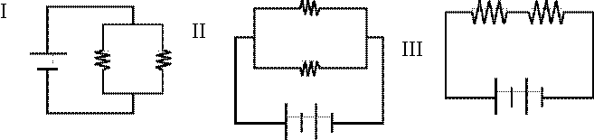
Drawings:
- Label the circuits shown to the right as either series, parallel, or both.

- Draw a series circuit with 2 batteries and two lightbulbs with a resistance of 5 Ω each, and an open switch.

- Draw a parallel circuit with 3 batteries, 3 branches each with a light bulb. The resistance of each light bulb is 2 Ω.

- What will happen if a bulb is removed from each circuit? Be specific.
  - The series circuit –

  - The parallel circuit -

- What are benefits for using a parallel circuit as opposed to a series circuit?

Calculations: SHOW YOUR WORK OR YOU DON’T GET CREDIT
- A clothes dryer is equipped with an electric heater that works by passing air across an electric wire that is hot because of the current in it. The wire’s resistance is 10.0Ω, and the current in the wire equals 24 A. What is the voltage across the heater wire?

- An electric car is equipped with a motor that can deliver 50 hp. The voltage across the motor’s terminals equals 500 V, and the resistance in the motor’s circuit is 7.5 Ω. How large is the current in the motor?

- A TV is plugged into a 120V outlet. The current in the TV is equal to 0.75 A. What is the overall resistance of the TV?

- A refrigerator’s circuit has a current equal to 0.647 A in it when the voltage across the circuit equals 116 V. What is the resistance of the circuit?

- A window-unit air conditioner has an overall resistance of 22 Ω. If the voltage across the air conditioner equals 115 V, what is the current in the air conditioner’s circuit?

- A washing machine motor works because of a current of 9.8 A in a circuit with a resistance of 12.2 Ω. What is the voltage across the terminal?

Drawings AND Calculations:
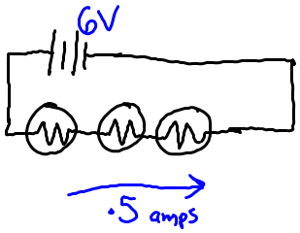
- Use the drawing to the right to answer the following questions.
  - What is the voltage of each battery?

  - Calculate the total resistance in the circuit.

  - What is the individual resistance in each resistor?

  - Calculate the voltage drop across EACH resistor.

- Use the drawing to the right to answer the following questions.
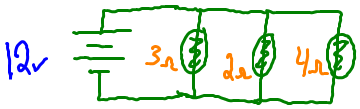
  - What is the voltage passing through each branch?

  - What is the current passing through each branch?

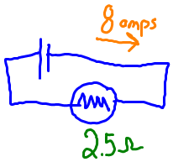
- Use the drawing to the right to answer the following questions.
  - What is the voltage in the following circuit?

  - Is this a Series or Parallel Circuit?

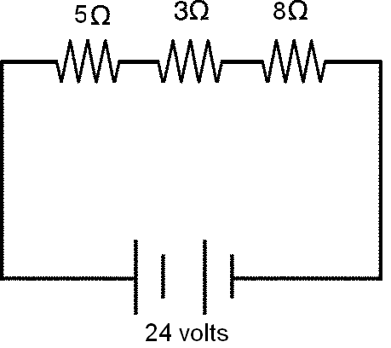
- Use the drawing to the right to answer the following questions.
  - What is the voltage of each battery?

  - Calculate the total resistance in the circuit.

  - Calculate the current in the circuit.

  - Calculate the voltage drop across EACH resistor.

- All magnets have 2 poles. Name them:

- If a magnet is cut in half, each piece will still have:

- Motors change _______________ energy into _______________ energy.

- Generators change ____________ energy into ________________ energy.

- List the 2 ways in which you increase the strength of an electromagnet.

