Unit 5 - Speed and Acceleration Study Guide

PART 1: CONCEPTS
- What is viscosity?

- Will heating up an object increase or decrease the viscosity of the substance?

- Does the speedometer of a car read average speed or instantaneous speed? How do you know?

- What is the acceleration of a car that travels in a straight line at a constant speed?

- If we were to graph the above acceleration, what would the graph look like?

- What is the acceleration of a car that is slowing down for a red light?

- If we were to graph the above acceleration, what would the graph look like?

- Explain to me how a car can be accelerating if it is moving at a constant speed (notice I did not say "velocity").

- How can you tell the difference between a speed graph and an acceleration graph? (Hint: what is different about the axis for the graphs?)

- What is the difference between a scalar and a vector?

- What is a vector showing?

- (HONORS) What is momentum?

- (HONORS) What are our units for momentum?

- (HONORS) What is the law of conservation of momentum?

PART 2: PRACTICE Complete the following problems. Show all work and include units in your answer!

- A roller coaster car rapidly picks up velocity as it rolls down a slope. As it starts down the slope, its speed is 4 m/s. But 3 seconds later, at the bottom of the slope, its speed is 22 m/s. What is its average acceleration?

- A lizard accelerates from an initial velocity of 2 m/s for 4 seconds. The lizard’s average acceleration was 2m/s². What velocity did the lizard reach?

- If you are 16 miles from Charleston, how long will it take to get there if your average velocity is 42 miles per hour?

- If a diver falls off of a 10 meter platform diving board. He accelerates towards the water at 9.8m/s² for 1.6 seconds. What is the (magnitude of the) velocity of the diver when he hits the water?

- Imagine you are traveling to Chicago, and you pass a mile marker that says you have 191 miles to go. How long will it take you to get to Chicago if your average velocity for the rest of the trip is 66 mi/h?

- How far (in meters) will you travel in 3 minutes running at a rate of 6 m/s?

- A bicyclist is riding in a hilly area. She approaches a hill, and when she arrives at the bottom of the hill she is traveling at a velocity of 15.0 m/s. After 1.0 minutes, she arrives at the top of the hill, and her velocity is now 7.0 m/s. What is her average acceleration in m/s²?

- A puppy is chasing a ball being thrown. If he runs east for 8m, and then returns 5m west after the moving ball, what is his total displacement?

- If a wide receiver is running a deep pass pattern that ends up being 55m, run in 5.8s. If his quarterback throws a pick because he under threw him, the wide receiver has to turn around and chase the defender in the opposite direction for 30 meters because the play stops. Draw me the vectors (head to toe) and calculate the resultant vector’s displacement. (Hint: this is on the same plane. Ie: there and back)

 | Scalar | Vector
Characterized by magnitude only
Characterized by magnitude and direction
Displacement
Velocity
118 mi/hr
Speed
Distance
8m south

Graphing!
Use the graph with the rubber ducky to answer the following questions.

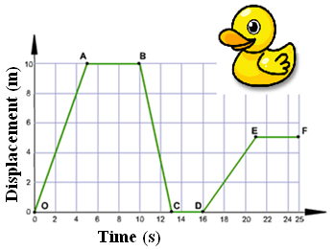
- Would a straight line on the graph to the right indicate a constant velocity or a constant acceleration? How can you tell?

- What is the displacement of the rubber ducky at point E?

- Explain to me what is happening on each of the following lines:
  - From point O to A –

  - From point A to B –

  - From point B to C –

  - From point C to D –

  - From point D to E –

  - From point E to F –

- What is the velocity of the line from point D to point E?

Use the graph with the school bus to answer the following questions.

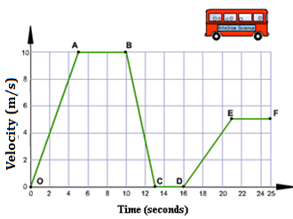
- Would a straight line on the graph to the right indicate a constant velocity or a constant acceleration? How can you tell?

- What is the velocity of the school bus at point E?

- Explain to me what is happening on each of the following lines:
  - From point O to A –

  - From point A to B –

  - From point B to C –

  - From point C to D –

  - From point D to E –

  - From point E to F –

- What is the acceleration of the line from point D to point E?

HONORS ONLY
- Iron man is one crazy super hero. I saw him flying directly towards a building for 220 meters in 1.8 seconds, keeping 1 meter off the ground the whole time. Once he reached a distance of 2 meters from the building, he hit some new thrusters and traveled directly upward to the top of the building 600 meters away, maintaining that 2 meter distance from the building for the entire 4.6 second it took to get from the ground to the top of the building. Draw me the vectors (head to toe), calculate the vectors velocity, and calculate the resultant vectors velocity.

- If an object has a momentum of 482 kg*m/s, what is the mass of the object knowing it is traveling at 11.4 m/s?

- Mr. Krausz is playing pool. He is lining up a shot that would win him the game (don’t worry kids, he won’t win). If his .45kg pool cue is traveling at 18m/s what will be the velocity of the 2.3kg pool ball when it is struck by the cue stick?

- Coach Smith is playing golf. He hits a tee shot 345 meters. If his 7.45kg golf club is traveling at 16m/s what will be the momentum of the .03kg golf ball after it is struck by the golf club? Assume 1 dimension and that there is a perfect conservation of energy. (Hint: what is the golf club’s momentum?)

- A linebacker is coming around the end to hit a stationary quarterback that is sitting in the pocket. The linebacker has a mass of 112kg and a speed of 7.9m/s, and the quarterback has a mass of 98kg and a velocity of 0m/s (stationary). After the hit, the linebacker has a speed of 3.5m/s. What is the speed of a quarterback after the hit (this is the speed he is knocked forward/tackled) (hint: Think about the law of conservation of momentum and what it really means.)

