Unit 4.1: Balancing Chemical Reactions
Notes for/from class

Further Reference: 7.1 and 7.2 – Chemical Equations

CHEMICAL CHANGES
- In a chemical change, you are going to ___________ bonds, ______________ those atoms, and _______________________.

- All chemical changes are a result of _______________________

  - Happen when you _______________________ bonds.
  - Involve _____________________ of atoms
  - One set of compounds (_________________) forms another set of compounds (________________________)

LAW OF CONSERVATION OF MATTER
- The law of conservation of matter states that matter cannot be _____________ or ______________, but it can only ____________________.

  - The number of each type of atom ________________________ must be ___________ to the number of each type of atom ____________________

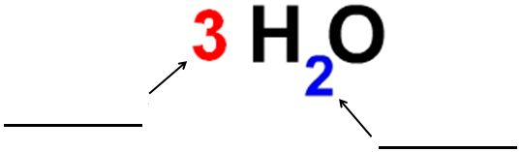
BEFORE WE BALANCE
- Complete the following figure:

  - Coefficient: ___________________________________________________

  - Subscript: ____________________________________________________
PreBalancing Practice: How many of each do you have?

2 H₂O₃ H = _______ O = _______
4 Fe₂O₃ Fe = _______ O = _______
6 NaCl Na = _______ Cl = _______
NO₂ N = _______ O = _______

BALANCING EQUATIONS
- _________________ on the left, _______________ on the right

- Symbols:
  - + means ______________________________________
  - means ______________________________________
  - g means ______________________________________
  - s means ______________________________________
  - l means ______________________________________
  - aq means ______________________________________

- When balancing chemical equations, you are not allowed to change the ____________________________
Notes for/from class
  - You CAN’T _____________________________

- You can only change the _______________________________ on each side of the equation
  - You CAN _________________________
- Practice: Use the T Chart below to balance the following equation
  - Magnesium (solid) + Oxygen (gas) Magnesium Oxide (solid)
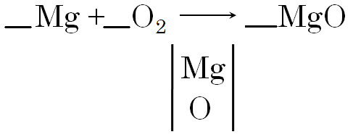

Balancing Practice: Using the provided T Charts, balance the following equations.

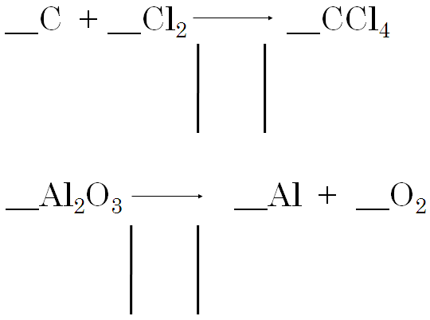

Unit 4.2: Chemical Reactions: Energy
Notes for/from class

Further Reference: 7.1 and 7.2 and 7.4 – Chemical Equations and Reaction Rates

ENERGY IN CHEMICAL REACTIONS
- All chemical reactions involve _____________________

- Every time a bond is ___________ or _____________, energy is used

  - Breaking bonds ______________ energy
    - Chemical reactions require energy _______________

  - Forming bonds ______________ energy

- Chemical energy is stored inside ______________________

  - The stronger the bond is, the ____________ it is to start the chemical reaction

- Energy is _________________________________

  - The energy within the _________________ and the __________________ must be the same as the energy within the ____________

HEAT ENERGY IN CHEMICAL REACTIONS
- Exothermic reactions _______________ energy and the temperature __________
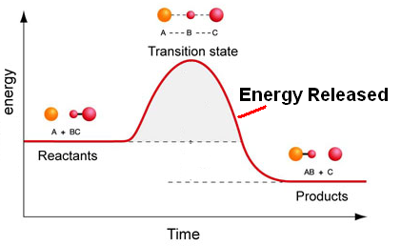
  - They _______________ heat!

  - Examples:
    - ___________________
    - ___________________
    - ___________________

- Endothermic reactions _______________ energy and the temperature __________
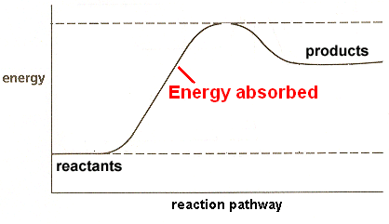
  - They _______________ heat!

  - Examples:
    - _____________________
    - _____________________
    - _____________________

PHOTOSYNTHESIS
Notes for/from class
- Photosynthesis is a _______________ reaction

  - Reactants are __________________ and __________________

  - Products are ___________________ and __________________

- Energy from the ___________ is being transformed into __________________, which is being stored as _____________________
Show the formula for photosynthesis (without the coefficients!)

_______________ + ______________ ____________ + _____________

SPEEDING UP REACTIONS
- The following actions __________________ the rate of reactions because they ___________________________!
  - Increasing ________________________________
  - Increasing ________________________________
  - Increasing ________________________________
  - Increasing ________________________________
  - AND ______________________.

CATALYST
- A CATALYST is a substance that _______________________________________

  - It does this by lowering the ________________________ of a chem rxn.

  - A catalyst is never ________________ and never__________________

  - Think of it as a _____________, like a _______________

    - Each catalyst has only _____________________________

- Enzymes are merely ________________ that work ____________________

  - Just like catalysts, each enzyme has _______________________

  - Substrate: the ________________ an enzyme _________________

  - Essentially, the enzyme and substrate are like a ___________________

Unit 4.3: Types of Chemical Reactions
Notes for/from class

Future Reference: 7.3 Nature of Chemical Reactions

Classifying Reactions
- Synthesis (Addition) Reactions:
  - Describe it in your own words:

  - Write the example using A, B, C, D, X, etc…

  - Write a real world example found in the notes:

- Decomposition Reactions:
  - Describe it in your own words:

  - Write the example using A, B, C, D, X, etc…

  - Write a real world example found in your in the notes:

- Single Displacement (Replacement) Reactions:
  - Describe it in your own words:

  - Write the example using A, B, C, D, X, etc…

  - Write a real world example found in the notes:

- Double Displacement (Replacement) Reactions:
Notes for/from class
  - Describe it in your own words:

  - Write the example using A, B, C, D, X, etc…

  - Write a real world example found in the notes:

- Acid Base Reactions:
  - Describe it in your own words:

  - Write the example using A, B, C, D, X, etc…

  - Write a real world example found in the notes:

Q1 – What 2 things does an Acid Base Reaction ALWAYS result in?

- Combustion Reactions:
  - Describe it in your own words:

  - Write a real world example:

  - What are the two products of combustion EVERY TIME?

Q2 – What is ALWAYS going to be the non chemical product of a combustion reaction?

Unit 4.4: Translation
Notes for/from class

Further Reference: Google.

TRANSLATION
- Translating is when I give you a __________________ that you have to turn into an equation written _______________________

- Hints:
  - Diatomic molecules are always written as:
    - ____________________________________

  - Words like ___________, _____________, ____________ mean put a + into the equation

  - Words like ___________, ______________, ___________ mean put a into the equation

TRANSLATING PRACTICE (DO NOT BALANCE)
- Potassium bromide potassium metal + bromide

- Calcium fluoride Calcium + fluoride

- Hydrogen reacts with oxygen to produce water.

- Silicon tetrachloride decomposes into silicon and chlorine.

