Scalars and Vectors: Intro and Practice

A scalar quantity is a quantity that is fully described by its magnitude. On the other hand, a vector quantity is a quantity that is fully described by both magnitude and direction.

- What is a scalar?

- Is a scalar an example of speed or velocity?

- What is a vector?

- Is a vector an example of speed or velocity?

So tell me if each of the following is scalar or vector:
- 5 m 8. 17 m/s

- 30 m/sec, East 9. 110 ft

- 5 mi., North 10. 20 mi/hr north by northwest

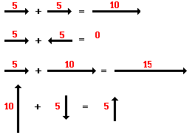
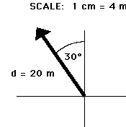
A vector is usually represented by a vector diagram (as shown to the left). Vector diagrams depict a vector by use of an arrow drawn to scale in a specific direction. The length of the arrow indicates the magnitude of the vector, while the angle of the vector indicates the direction. Two vectors can be added together to determine the resultant (as shown below).

So let’s try adding together some vectors that are on the same plane.

- 4m 5m 13. 4m 8m
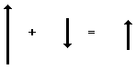
- 3m 6m 14.
8m 4m

- A car is traveling 8 km to the north and turns around to travel 3 km south. Draw the vectors (head to tail) and solve for the resultant displacement.

- A runner is moving 8 m/s to the east and goes around a tree. She then moves 5 m/s to the west. Draw the vectors (head to tail) and solve for the resultant velocity.

- A fighter jet is chasing an enemy plane, and flies straight up at for 2000 m. However, the plane stalls and begins to fall straight down for 5000 m. Draw the vectors (head to tail) and solve for the resultant displacement.

